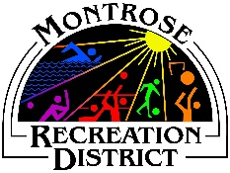
Staff “Above and Beyond” Nomination Form
The employees of the Montrose Recreation District work as a team to provide the best programs, facilities and services possible. Often, our team members go that extra step and provide service that is above and beyond expectations.
Each month, the Above and Beyond program recognizes an extraordinary MRD staff member. The criteria for nomination might include:
- Solved a problem or improved a process, resulting in increased customer satisfaction or cost savings.
- Put forth extra effort to complete a task or handle a heavier workload
- Volunteered for, or worked on a special project
- Facilitated and assisted in interdepartmental and customer relationships
- Fostered collaboration, communication and cooperation between departments and patron user groups.
- Promoted, improved, and/or enhanced customer satisfaction.

Employee’s name: ____________________________________________________
Date or time period of the extraordinary effort: _____________________________
Nominator’s name: ____________________________________________________
Reason for nomination: _________________________________________________

______________________________________________________________________
______________________________________________________________________
______________________________________________________________________
______________________________________________________________________
______________________________________________________________________
______________________________________________________________________
Use back of page if needed.

