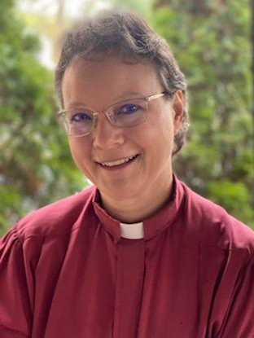
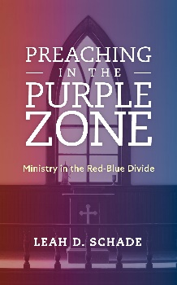
THE REV. DR. LEAH D. SCHADE

Speaker, Author, Preacher, Professor

Preaching * Political Divides * Dialogue * Research
1424 Jocasta Dr., Lexington, KY 40517
610-420-6861 (cell)
lschade@lextheo.edu

Bio: The Rev. Dr. Leah D. Schade is the Associate Professor of Preaching and Worship at Lexington Theological Seminary in Lexington, Kentucky, and served as the President of the Academy of Homiletics in 2024. An ordained Lutheran minister (ELCA) for nearly twenty-five years, Leah earned both her MDiv and PhD degrees from the Lutheran Theological Seminary at Philadelphia (now United Lutheran Seminary). She has pastored congregations in suburban, urban, and rural contexts. She has authored or co-edited seven books, including Preaching and Social Issues: Tools and Tactics for Empowering Your Prophetic Voice (Rowman & Littlefield, 2025), Preaching in the Purple Zone: Ministry in the Red-Blue Divide (Rowman & Littlefield, 2019). Her preaching textbook, Introduction to Preaching: Scripture, Theology, and Sermon Preparation, was co-authored with Jerry L. Sumney and Emily Askew (Rowman & Littlefield, 2023).
Dr. Schade received a $30,000 grant from the Wabash Center for Teaching and Learning in Theology and Religion to study deliberative dialogue in classrooms and congregations. She is leading a research project on ministry, preaching, and social issues that has surveyed nearly 4,000 clergy and 1,000 laity since 2017. She is currently the director of a $1.25 million grant from Lilly Foundation, Inc. for the project, “Compelling Preaching for a Climate-Changed World,” in partnership with Lexington Theological Seminary, The BTS Center, and Climate Justice Ministries. Dr. Schade is a recipient of the Kentucky Council of Churches award and is the EcoPreacher blogger for Patheos.

Prophetic Preaching in a “Plaid Parish”

Like a cross-barred pattern of fabric where the colors do not mix, a “plaid parish” is marked by lines that separate our differences and checker our shared faith. Preachers need fresh insights from Scripture that can offer us wisdom amid our fractured society. Rev. Dr. Leah Schade, associate professor of preaching and worship, will offer tools for ministry in politically divided congregations that can open up opportunities to proclaim the gospel and build community in profound and contextual ways.

SESSION ONE (Sunday evening) -- Ministry in a House Divided: An Overview of the Frayed Fabric
Red state/blue state politics threaten the foundations of our democracy and tear the fabric of our churches. Congregations and church leaders need new perspectives and insights for navigating this difficult time. Rev. Dr. Leah Schade will offer an overview of “the plaid parish” in the U.S. based her longitudinal research of nearly 4000 clergy and 1000 laity from 2017-2025. She will then introduce strategies and methods for engaging issues of public concern that enable congregations to find the values that bind them together and respond faithfully to God’s Word.

SESSION TWO (Monday morning) -- Preaching and Social Issues: Tools and Tactics for Empowering Your Prophetic Voice
How can preachers address social issues in their sermons given the divisiveness and polarization in society and churches? Rev. Dr. Leah Schade will equip preachers to craft sermons that help congregations talk about topics of public concern based on a strong biblical foundation, solid theological claims, and prudent sermonic strategies. Drawing from insights and wisdom gained from years of research with clergy and congregations, Dr. Schade will provide practical and pastoral guidance for preachers to find their voice to address social issues with justice and love. They will learn three approaches to a sermon addressing a social issue: Gentle, Invitational, and Robust, based on the preacher’s strengths and vulnerabilites, characteristics of the congregation, and the quality of relationships between and among the congregation and preacher. In preparation for this session, participants are requested to take this 5-minute Assessment Tool for Prophetic Preaching: https://www.surveymonkey.com/r/PreachingSocialIssuesAssessment
SESSION THREE (Monday afternoon) -- Finding Your Path to Prophetic Preaching: Text Studies for Sermons on Social Issues
As our country faces multiple economic, governmental, social, environmental, and global crises, attacks against those most vulnerable and the clergy and denominations who minister to them raise an important question: how can pastors preach in this precarious time? Rev. Dr. Leah Schade will lead participants through a study of upcoming lectionary texts with options for using the Gentle, Invitational, and Robust approaches to preaching.

