The Wisconsin Conference UCC can support and strengthen the faithful ministry of congregations like ours because of our gifts to OCWM Wisconsin Impact (formerly, OCWM Basic Support). This mission often means supporting people as they take on greater roles in their congregations or discern a call to ministry.

Randy Koppenhaver, a middle school teacher in his rural community, loved his local congregation, Bethlehem UCC. His pastor saw his dedication to church. She encouraged him to explore his faith through Lay Academy (now the Damascus Project). The program helped him grow spiritually and deepen his leadership skills.

During a pastoral transition, the church moderator asked Randy to lead worship and preach. What began as pulpit supply grew into a regular call.

The Committee on Ministry, along with mentors from the area, encouraged Randy’s development. “At first, when I looked at the requirements, I thought, ‘Oh my gosh, this is overwhelming,’” he said. Support from the Conference made the daunting work manageable. Moving away to attend seminary didn’t make sense. Instead, the Conference offered an alternative path through the Lay Academy and then the Damascus Project. The Conference also provided scholarships to make it affordable. “The whole process helped me grow and informed my ministry today,” Randy said.

Beyond preparing Randy for ministry, the Conference continues to support him through the Community of Practice program. The program gathers pastors together for regular support, peer learning, and reflection.

Eight years after his journey began, Randy was ordained at Bethlehem UCC, where he now serves as the settled pastor. (That’s Randy in the center of the photo.)

The Conference can support the leadership development of pastors like Randy because of the generous gifts of our congregation to OCWM Wisconsin Impact. By working together, we can ensure faithful leaders for our congregations.
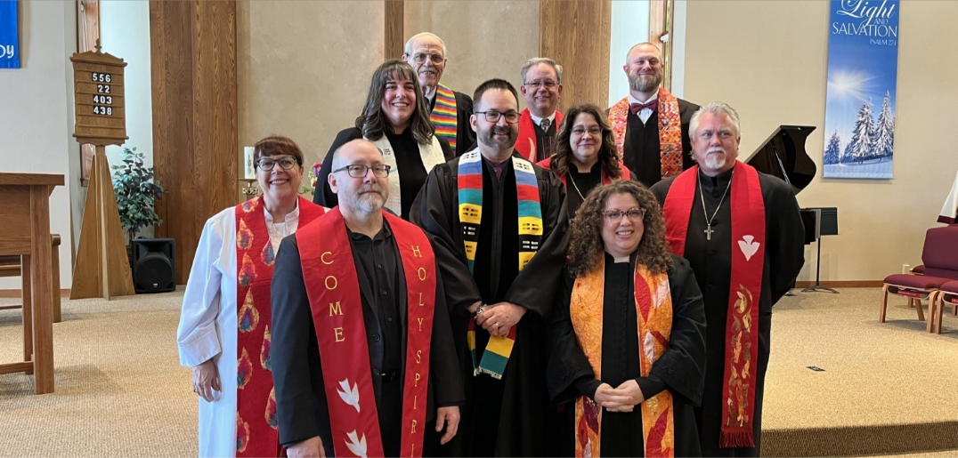OCWM Wisconsin Impact, formerly known as OCWM Basic Support, funds the wider mission and ministry of the United Church of Christ. Because of our gifts to OCWM Wisconsin Impact, the Wisconsin Conference can support the vitality of congregations like ours. A portion of OCWM Wisconsin Impact goes to regional missions like United Church Camps, Inc. (outdoor ministry) and the National Ministries of the UCC.

