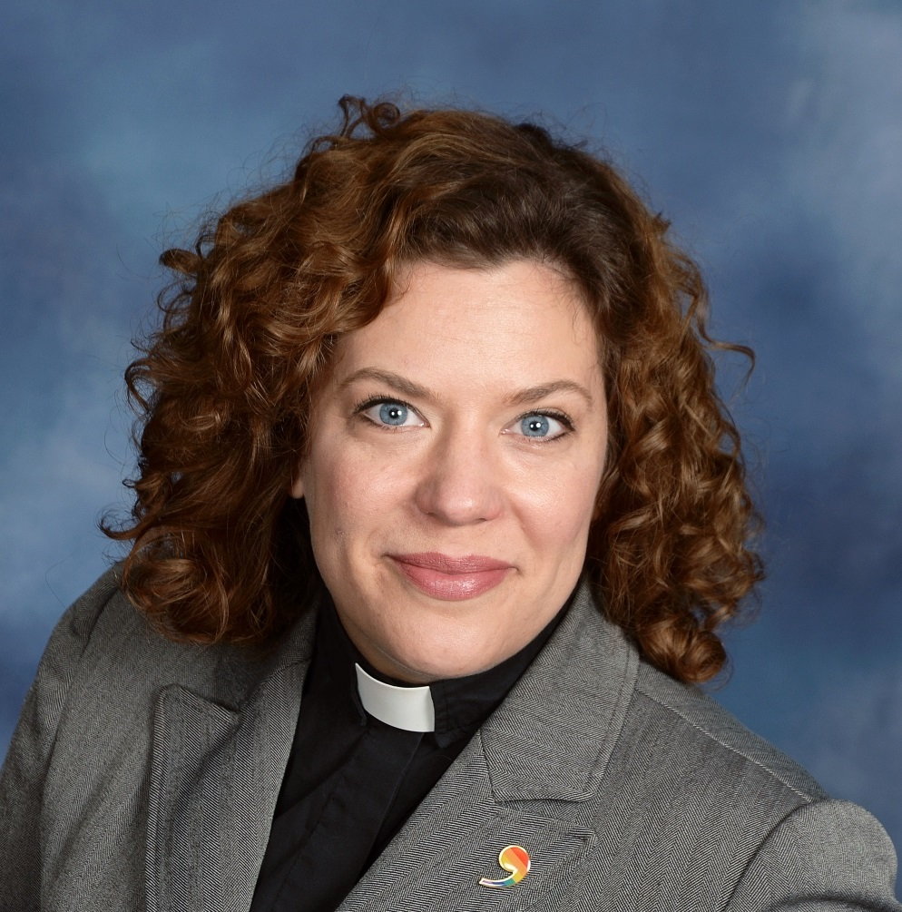
Hone your Conflict Transformation Skills
The Damascus Project is partnering with Rev. Elena Larssen to offer a 4-week workshop titled “Conflict Transformation: When Agreement isn’t Enough.” This workshop is unit 4 in our 2022 Leadership Skills series. It features a combination of self-guided work online and 6 hours of communal learning using Zoom.
Workshop Description:
To live in “interesting times” is a burden and a blessing, and both can mean conflict as change takes a toll on God’s people. This course will cover popular concepts of conflict transformation, both interpersonal and community based. Emphasis will be placed on self-knowledge, prayerful practices, and the role of a lay leader in church conflict.
Workshop Dates: April 28-May 26, 2022
Live Zoom Sessions: Friday, May 13, 6:00–8:00 pm; Saturday, May 14, 10:00 am–12:00 pm and 1:00–3:00 pm
Cost: $154
To register or for more information, go to www.the-damascus-project.org
Questions? Email info@the-damascus-project.org, or call 507-222-0194.

