Save the Date - Freshwater Faithworks
New for summer 2026 - Intergenerational Camp and Middle School Adventure

Intergenerational Camp
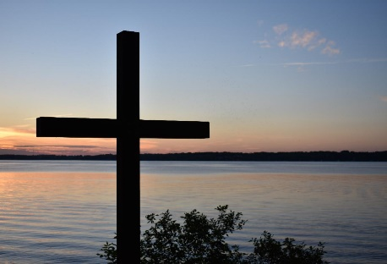
June 28 to July 1 | Daycholah Center on Green Lake, WI
Cost: $400 for Adults
$250 for Youth ages 12-18
$125 for Children ages 3-11
Free for children under 3

Registration will open in early April!

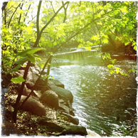
Middle School Adventure
July 29 to August2 | Creekside UCC, Minneapolis & First United Church of Little Falls
Cost: $75 for youth and $25 for adults
Registration will open in early April!

Freshwater Faithworks is a new summer program focusing on the intersection of freshwater ecology and faith. In experiences ranging from a three-night intergenerational camp (June 28-July1) to a four-night middle school trip (July 29-August 2), we will explore the importance and sanctity of our water sources and how human activity affects the health of our waterways for better or worse. With a combination of hands-on service-learning, education, exploration, and reflection, participants will be given the opportunity to experience freshwater sources in a wholistic way, inviting them to fall in love with water and empowering them to fight back against climate anxiety with tangible action.

Please contact Lisa Hart, Associate Conference Minister for Faith Formation and Justice Ministries, at lhart@wcucc.org with questions about these events.

Freshwater Faithworks is a collaboration between the Minnesota and Wisconsin Conferences of the United Church of Christ.

