When we baptize someone into our faith, the people gathered for worship say to the newly baptized, “We promise our love, support, and care.” Our support of OCWM Basic Support helps to make that promise a reality.

Lisa Hart, Associate Conference Minister for Faith Formation and Justice Ministries, hosted a training for Our Whole Lives at the Daycholah Center in August. Our Whole Lives is a comprehensive lifespan sexuality curriculum produced by the United Church of Christ and the Unitarian Universalist Association. “The church has a responsibility to help people get factual information about their bodies, to empower them to make decisions for themselves, and to learn how to show care for others,” Lisa says.

The leaders trained at the OWL retreat will become facilitators in their local congregations. Working with groups of children, youth and adults, they provide accurate, age-appropriate information that helps participants make informed and responsible decisions about their relationships, sexual health and behavior in the context of their faith.

“Now that I spent a weekend learning about the Our Whole Lives sexuality program, I am so excited to share these resources with our youth,” said the Rev. Julia Hollister of First Congregational in Sheboygan, reflecting on her experience at the retreat. “I look forward to all the crucial conversations that will be generated through our engagement with this material that affirms body and soul."
The Daycholah Center provided leaders the gracious space they needed to learn new ways of talking about human sexuality. “Many of our participants commented on how restorative the weekend was,” said Amy Johnson an OWL training and Minister for Sexuality Education and Justice with the National Setting of the UCC. “That is unusual for our trainings because they are so full in content and time-intense over a weekend. I am convinced that having these trainings at Daycholah Center significantly contributed to the restoration and healing that happened over the weekend.”

Whether it’s an OWL Training or one of the many other programs offered by the Wisconsin Conference, the gifts of your congregation to OCWM Basic Support make possible all the work of the UCC beyond your local congregation and strengthen the ministry of your congregation.

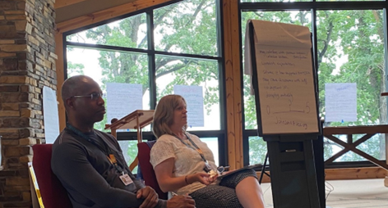 Cedric Harmon and Amy Johnson, OWL trainers at the Daycholah Center

