The Wisconsin Conference UCC supports and strengthens the faithful ministry of congregations throughout our state. The Wisconsin Conference can do this because of our gifts to OCWM Basic Support.

The Wisconsin Conference organizes programs like Youth Faith Formation Retreats. Youths loved the opportunity to gather again at the beautiful Daycholah Center of United Church Camps, Inc.

A retreat in March focused on “Journeys of Faith.” Young people creatively explored biblical stories of people who made journeys, then engaged in spiritual practices to help explore their personal faith journeys. “The ‘Letting Go’ prayer station was meaningful,” one youth said. “I could really feel it when I held the rocks and thought about all the stress and burdens I hold on to. It felt good to let those go.”

Time spent with members of their own congregations allowed youths to go more deeply into their own stories. “I think I need to forgive God before I can go any further with this,” one said.

Many participants came from congregations with few other young people. The retreat connected them with peers. “I made new friends,” one person said. “It felt good to be here with a large group of kids.”

The Rev. Julie Eklund saw the impact of the retreat on participants from her congregation (photo below). “Our confirmation class had just completed our Spiritual Practices Class the week before we left for camp,” Julie said. “They really connected what they learned with the activities and opportunities at camp. The Spirit moves!”

Our gifts to OCWM Basic Support make an impact on congregations throughout Wisconsin through programs like the Youth Faith Formation Retreats. By working together, we can provide meaningful and engaging programs that best serve all our congregations.

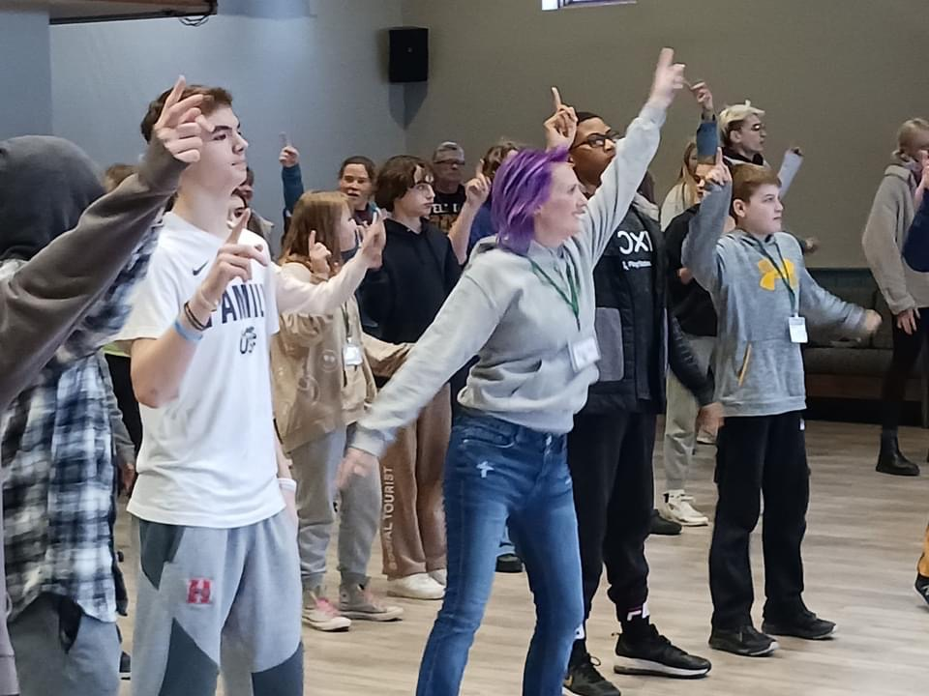

Learn more about the Wisconsin Conference UCC at
www.wcucc.org

