Everyone is Welcome!

Blue Christmas Service
Tuesday, December 16 @ 7:00pm

Emanuel United Church of Christ
10627 West Forest Home Ave.
Hales Corners, WI

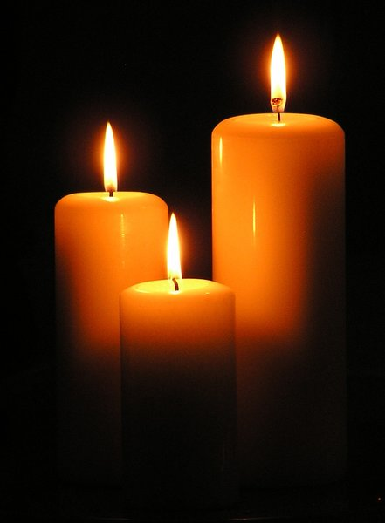
For those grieving, wrestling with life issues, feeling loneliness or disheartened by the chaos in the world. For those who may have little heart for the cheer and bustle of the Advent and Christmas seasons in December.
This quiet worship recognizes the emotional struggles we sometimes face during the holiday season.
It offers comfort, healing, hope,
and the knowledge we are not alone.

JOIN US AND INVITE OTHERS

