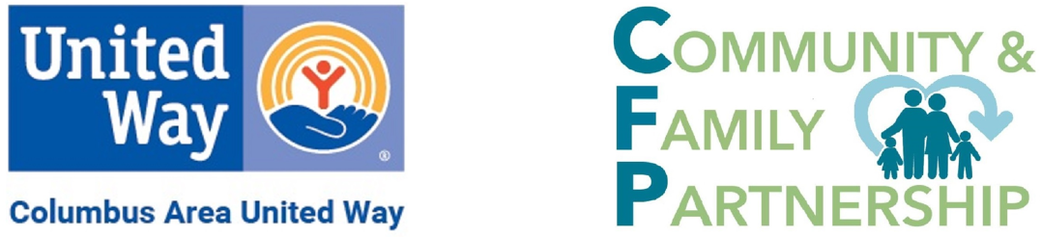

Community & Family Partnership Collaborative Meeting notes

October 7, 2026 9:00 a.m. – 12:00 p.m.

Columbus Community Building, 2500 14th Street, Columbus

Third floor conference room

9:00 a.m. Welcome – Rob Clay, Platte Valley Literacy Association
Rob welcomed us in Arabic and encouraged us to consider that people coming to our county have a lot to learn ~ even road signs! He briefly mentioned some of the services at PVLA.
9:10 – 10:00 a.m. Court Improvement Project and recent Platte County Mapping Upstream Meeting – Carrie Hastreiter, Platte County Juvenile Diversion Program
Mutually Reinforcing Activities, Continuous Communication

Carrie provided the background for the Platte County Mapping Upstream meeting held in September. Judge Flaherty and Judge Kracl were instrumental in convening this meeting. Roughly 50 people were in attendance on the first day with about 35 on day two. A lot of fruitful conversation during his two day meeting about how we/community can wrap around services for juveniles and their families. Three work groups were created from this meeting.

School Collaboration – Sonya Sukup, LMHP Dept Coordinator, ESU7

Point person in schools for communication. There will be a February 2027 meeting to coming up to connect the CAUW and other entities together. The team talked about navigation services and possibly having them at parent teacher conferences in the future.
Support for Families – Karmen VanDeWalle, The Well
This group focused on where families can find support, places where families feel welcome and comfortable and who feels left out. Families need a clear way to connect. Next step is to compile information on what’s out there in our community into an already created NCFF dashboard. Enhance communication, where support for families can be found.
Response to Mental Health Needs – Carrie Hastreiter
The overall goal is to identify youth struggling with mental health needs and to connect to youth earlier. Social workers or navigators at P/T Conferences.
10:00 – 11:15 a.m. Connecting People to Resources & Use of Connectors to Resources and Intentional Connection Common Agenda, Mutually Reinforcing Activities, Backbone Support

Directory of Services
Find Help – Part of Warm Line
2-1-1
Hope described the three services listed above.

Questions were posed to the group with the responses provided below.

What are challenges for getting families connected to resources?
Barriers: Transportation, qualifying, hours/closed, resources in other counties, shame, affordability, language, wait time for benefits, waited too long to seek help, mental health, addictions, follow-through, disability, age eligibility, resource limitations, getting/sharing the whole story, prioritizing needs, employment, convictions, record, trust

What would a resource system designed by families look like?
Universal application, share story once, ability to meet families where they are (community centers, workforce, church, schools, grocery stores, etc.), empowered to be self-sufficient, one stop shop, 24 hours, care for small children while seeking services, interpreters always available/multi-lingual staff, mentor/navigator to walk through process, unlimited funding

What can we stop?
Doing for instead of teaching, stopping silos, expecting help from federal government, inconsistent referral systems (individual), what we’ve always done, asking the same questions, making families repeat their story, making assumptions, assuming we’re the experts, normalizing the barriers
Most important component in building family-support system.

Comprehensive, awareness of resources, sustainable, efficient, respectful, consistency, simple/clear/easy, accessible, self-sufficiency, proactive, cohesive, reliable, empathetic, flexible
A summation of the 10:00 – 11:15 a.m. conversation follows:

Challenging Assumptions and Transforming Systems
Partners engaged in a thoughtful discussion about the barriers families face when seeking support and explored how systems could be redesigned to better meet family needs. Participants reflected on their own experiences accessing services and identified a range of challenges that families commonly encounter, including transportation, language barriers, rural location and limited local resources, affordability concerns, stigma, eligibility requirements, long wait times for benefits, employment constraints, behavioral health challenges, and difficulties navigating complex systems. Trust and the need for stronger advocacy and support throughout the process were recurring themes.
As the conversation shifted toward innovation, attendees envisioned what a family-designed support system might look like. Participants emphasized the importance of a universal application process, allowing families to share their stories only once while agencies coordinate behind the scenes. They imagined services being available where families already spend their time, such as schools, community centers, workplaces, grocery stores, faith communities, and other neighborhood locations. Other priorities included multilingual and interpretation services, family navigators or mentors to walk alongside families, childcare during appointments, extended service hours, and approaches that empower families toward long-term self-sufficiency through coaching and support.
Collaborative members also challenged long-standing assumptions about the current system. Participants noted the need to move away from siloed services, repetitive intake processes, individual referral systems, and practices that require families to repeatedly retell difficult experiences. They encouraged professionals to avoid assumptions, recognize family expertise, and stop accepting unnecessary barriers as normal parts of accessing support.
When asked to identify the most important elements of an ideal family-support system, participants described a vision that is comprehensive, accessible, reliable, sustainable, respectful, empathetic, flexible, proactive, and cohesive. Above all, attendees emphasized the importance of creating a system that is simple to navigate, responsive to family needs, and built on relationships, trust, and shared understanding.
Key Takeaway: The discussion highlighted a collective desire to shift from fragmented, program-centered approaches toward a coordinated, family-centered system that reduces burdens, strengthens relationships, and makes support easier to access for all families.
11:15 – 11:30 a.m. ALICE – Asset Limited Income Constrained Employed, Hope Freshour, Executive Director, CAUW Common Agenda, Shared Measurement
County and national data, launching in Nebraska in the new year. This data will help with applying for grants, and education with partners, business, government sectors and more.
11:30 – 11:40 a.m. Volunteer Connect – CAUW Nicolette and/or Sara Continuous Communication
Website to connect volunteers to organizations with volunteer opportunities. Organizations can register for free and post their volunteer opportunities. Volunteers can find opportunities. Columbusunitedway.galaxydigital.com
11:40 – 11:55 a.m. Recharge and Rejuvenation with Karmen VanDeWalle, LMPH, The Well Common Agenda
11:55 a.m. – noon Wrap up
Adjourn

