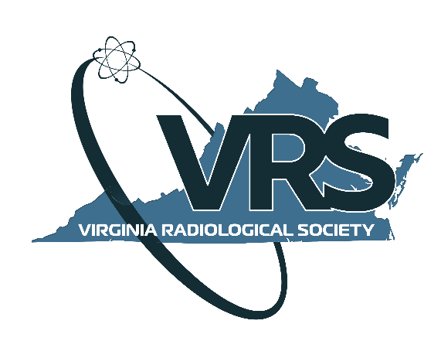

2021 ANNUAL MEETING | ABSTRACT SUBMISSION FORM

The Virginia Radiological Society Abstract Award Committee invites you to submit an abstract for consideration at our 2021 Annual Meeting which will take place on August 7-8, 2021 at the Jefferson Hotel in Richmond, Virginia.

CONTACT INFORMATION:

Author’s Name(s) & Degree(s): Click or tap here to enter text. (list all authors)
Presenter’s Name and Degree: Click or tap here to enter text.
Title of Abstract: Click or tap here to enter text.
Institution: Click or tap here to enter text.
Year of Residency: Click or tap here to enter text.
Preferred Mailing Address: Click or tap here to enter text.
Preferred Phone Number: Click or tap here to enter text.
Email Address: Click or tap here to enter text.

SPECIFICATIONS FOR ABSTRACTS:

Abstracts for the 2021 program must be submitted by May 28, 2021 at midnight. The submission should be no more than 2 pages, single space, 12-point type and include a title, introduction/objectives, materials and methods, results, and conclusion.

INSTRUCTIONS:

- Send this completed document as a Word file.
- Send a PDF file with the abstract title and abstract only without any identifying information (remove your contact information).
- Name both files as follows:
- <<Your Last Name>>VRS Abstract Submission Form
- <<Your Last Name>> VRS Abstract
- Send to: Lara Knowles at lknowles@ramdocs.org by midnight on May 28, 2021.

