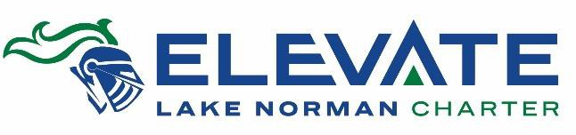
Lake Norman Charter School
EIN/Tax ID: 58-2360164
Elevate LNC Capital Campaign
12435 S. Old Statesville Road
Huntersville, NC 28078

Dear [Insert name],

On behalf of the students, families, and staff at Lake Norman Charter, I am requesting a donation to the Elevate LNC Capital Campaign to raise funds to improve our recreational spaces at our main campus, and increase our school security and expand instructional spaces at our middle school. My [son/daughter] is in [grade], and the wonderful community of educators at LNC is providing [him/her/them] with an exceptional educational experience similar to what is offered by private schools. Lake Norman Charter’s mission is to prepare students to be community leaders demonstrating personal integrity with a life-long desire to learn, lead and serve.

Our LNC students are not funded the same as other students. We receive no capital funding from the state for things like buildings and other facilities, which means we must do more with less. I ask that you consider supporting the Elevate LNC Capital Campaign. Our goal is to raise $2,400,000 by the end this year (in pledges and cash), so we can break ground in April 2020 and improve our facilities to make them a safer and more effective educational environment.

Our campus improvements will:
- Turf our field for greater use by PE classes, students at recess and our extra-curriculars like band and sports
- Replace our track with rubber substance for increased safety of our students and athletes
- Build a recreation structure outside with restrooms, locker rooms, concessions and more
- Repurpose our administrative office at our middle school for expanded instructional classrooms
- Improve student security at our middle school by creating a double buzz-in system to ensure no one who should not gain access to our school does
- Redesign our main campus drive for increased safety and traffic flow

Lake Norman Charter is a 501(c)(3) nonprofit organization, and all donations are tax deductible. By contributing, you will be helping build an environment where hundreds of students in the community each year are empowered and encouraged to realize their potential, own their academic success, and grow to excel as productive members of the business community and, perhaps more importantly, society at large .

My family has committed to a donation of [$ ] to the Elevate LNC Capital Campaign. I know we can meet this goal with your support. Would you consider making a donation and matching my contribution? Thank you for considering partnering with us to help us reach this goal.

Please visit https://www.lncharter.org/ElevateLNC to learn more and make a donation. Thank you in advance for your kindness and generosity.

Sincerely,

[Your Signature] [Your Name]

