Well-being with Yoga
(Anti-age Yoga)
by
Michela Franci

Here’s the bad news: as we get older, our bodies become less flexible, less stable, weaker, slower and less able to combat fatigue. As we get older, we lose the elasticity in our muscles and skin. Two of the most common results of the aging process are the loss of muscle mass (sarcopenia) and the loss of bone mass (osteopenia). These lead to a loss of speed and strength.

The good news is that even as we age it is still possible to build muscle mass, and it’s not too late to do so. There are specific yoga sequences that can help us by means of positions “of strength” which, making use of the weight of the body, call into play very specific muscle masses and related bones and tissues.

Standing positions (Utthita Sthiti) are particularly appropriate and especially those that are monopodalic (with all the weight on one leg), such as Vrksasana, known as the Tree pose.

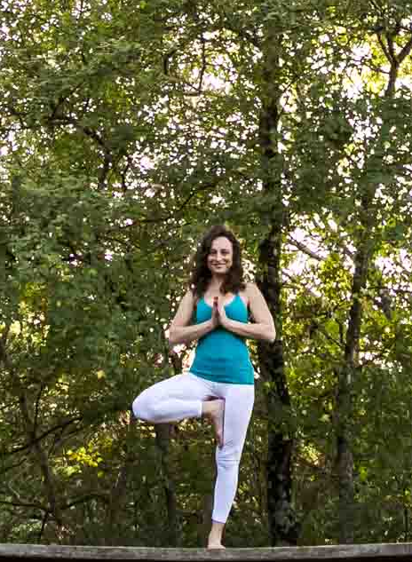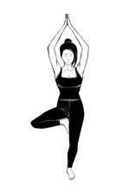

Some of these beneficial positions may be considered quite difficult. But do not fear! It’s possible to practise them all the same, thanks to the various supports (props) that the Iyengar method makes available. For example, Urdhva Dhanurasana (Bow pose).

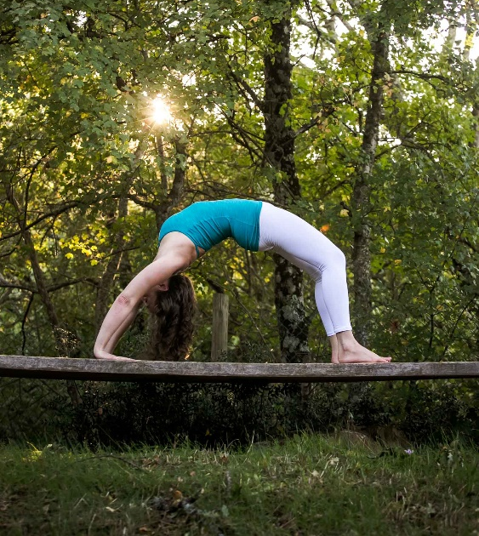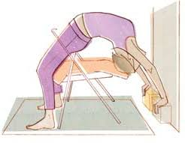

Sitting at a desk in front of a computer for many years leads to kyphosis, that is to say, a progressive forward-leaning deformation of the vertebral column, which tends to worsen with age. This creates neck pain due to a shortening of the extensor muscles. It also tends to reduce the space between the anterior ribs, which consequently reduces lung capacity. Back bending positions offer an opportunity to effectively counter this degenerative process, thus keeping us young!

The action of drawing the inner heads of the femur bones into the center back of the hip sockets
creates space between the buttocks and helps to lengthen the lumbar area: the hamstrings (the posterior thigh muscles) and the buttock muscles are toned, which protects the lumbar region.

Back bending positions provide two important benefits: they resolve back aches caused by hernias or protusions, above all in the lumbar area. In addition, they expand the front of the chest, strengthening the muscles of the dorsal spine.

It is advisable to practise back bending positions, under the guidance of a qualified teacher, with the help of specific props, such as a chair, belt or bolster, as these supports make the positions accessible to one and all, even those who are not flexible. In this way, even the not so young and those with postural problems can safely do the classical yoga positions, benefiting from the great advantages they bring.

This method – aiming at a more friendly access to back bending positions – enables us to regenerate our bodies, thus turning back the biological clock: using the props in an appropriate manner (and here the role of a qualified teacher is fundamental) a miracle is possible!

