Monster Day Greeley
August 17

Monster Day returns to downtown Greeley on Saturday, August 17! This family-friendly celebration of all things “monster,” features dozens of creatures from our own famous monster-makers, Distortions Unlimited, including the Greeley Gremlin and his pal Chewbie. Plus music, entertainment, face painting, a costume contest, Ed Edmunds speed painting masks, a sculpt-off duel, demonstrations, a monster puppet show, dance performances, a chance to wander through Monster World (additional charge), fire spinners, kids activities and more! Times for the event are 11 a.m. – 8 p.m.
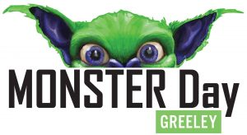

Don’t forget your camera, because the photo ops at Monster Day are out of this world. On top of the Distortions creatures all over the downtown plazas, there will be dozens of live monsters roaming about! (Don’t forget to share your photos with the #monsterdaygreeley hashtag)

And new this year, you can start the Monster Day festivities a little early because we’ll have some Monster Day shenanigans at Friday Fest on August 16. Enjoy a special performance by Peter, Paul, and (Scary) Gary on the 9th Street Plaza, enjoy Greeley’s famous Go-Cup, and fun for the whole family. Visit the Monster Daywebsite for more information!

