Greeley Area Chamber of Commerce
2019 Business to Business Trade Show
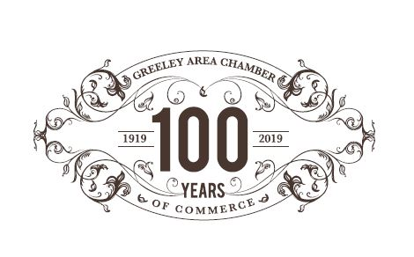

100 Years of Business at its Best!
Join us for a fun and productive evening of business connections
Monday, October 14, 2019
DoubleTree by Hilton Greeley at Lincoln Park
4:00 p.m. – 7:00 p.m.

Exhibitor Cost: $200
We have 65 booths available for exhibitors. Reservations are first come, first served and available to Chamber investors only.

THIS EVENT WILL BE OPEN TO THE PUBLIC

For event sponsorship opportunities please contact the Chamber
970-352-3566 or natyce@greeleychamber.com

Registration for Exhibitor Booths Due: September 30, 2019
Name of Business:
Contact:
Phone:
Address:
Email:
Need Electricity? Yes: ____ No: ____ $35 Pre Order/Discount Price – Day of Price: $45
All orders must be received by Thursday, October 3rd to qualify for the discounted price.

My Check is Enclosed: _____Charge My Credit Card _____
Name on Card: Billing Address:
Card #: Expiration: 3 Digit Code:
I would like to contribute a door prize of:
Circle One: Will bring day-of Will bring to Chamber before event
The following will be provided: One 6’ x 2 ½’ table, two chairs, table cloth, high speed wireless internet.
Some things you need to know:
- Only one business per table
- Feel free to provide printed materials, handouts/give-a-ways
- No confetti or glitter
- We will have a Bingo card to drive attendees to your table for eligibility for prize drawings!
- No signage or decor on walls
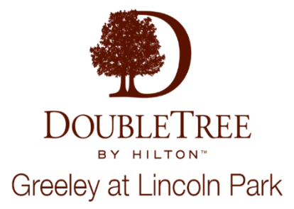
- Details regarding set-up/take-down will be sent once the application and your payment is received
Sponsored By:

