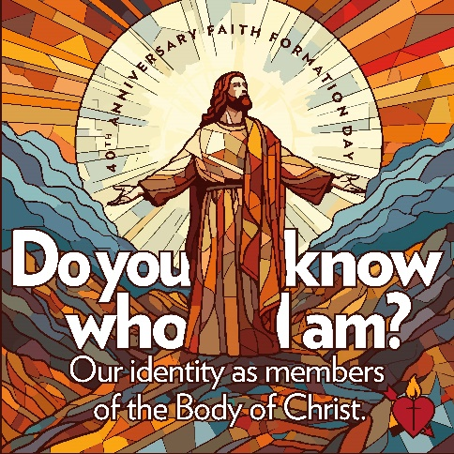
Catechetical Leader Calendar 2024-2025

August 6, 2024 Annual Retreat for DREs and other Ministers at Marywood
Presenter: Fr. Ben Berinti, CPPS

September 10 , 2024 Meeting 9:30 am – 2:00 pm
Mass with Bishop Pohlmeier
Wisdom Center at Marywood

September 15, 2024 Catechetical Sunday
“Lord, when did we see you hungry”?

TBD 11th Annual Western Faith Formation Day
Queen of Peace

October 5, 2024 40th Annual Faith Formation Day
Bishop John J. Snyder High School
Keynote: Dr. Kevin Dowd, sponsored by Pflaum
“Do you know who I am?”
Our identity as members of the Body of Christ

November 12, 2024 Meeting 10:00 – 2:00 pm
Catholic Center

January 14, 2025 Meeting 10:00 – 2:00 pm
Catholic Center

March 11, 2025 Meeting 10:00 – 2:00 pm
Catholic Center

May 13, 2025 Meeting 11:00 am – 2:00 pm
Social
Location TBD

