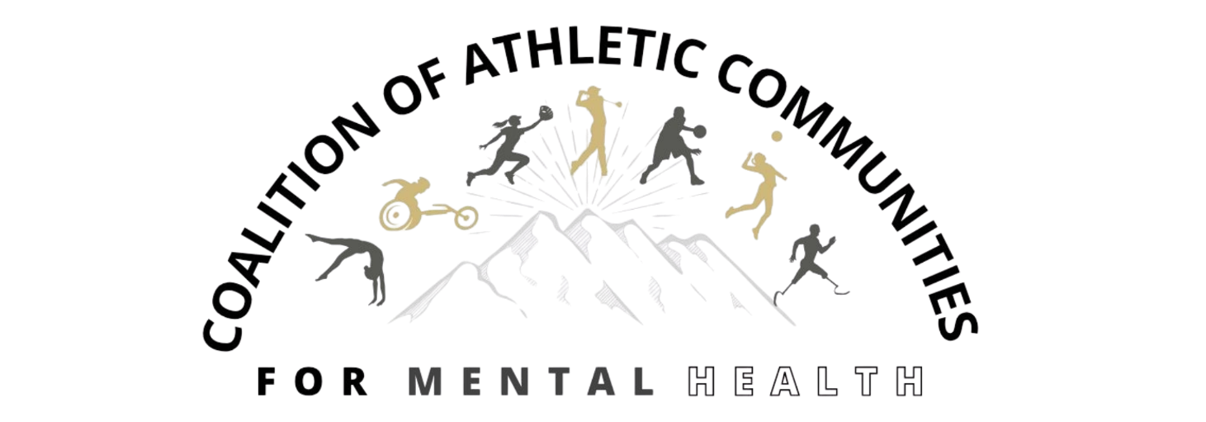
We’re proud to host the 2nd Annual Coalition of Athletic Communities for Mental Health (COACmH) Conference bringing athletes, researchers, subject matter experts, coaches and athletic staff, athletic trainers, parents and caregivers, health professionals, and other interested parties together to advance mental health in athletics.
The conference will focus on offering accessible information that comes from multi-disciplinary sources, has a multi-perspective lens, impacts all levels of sport, and is designed to move from awareness to understanding to action. The goal is to enhance the public good by changing the landscape in athletics to inform other audiences.

Join us for three days of research-driven conversations, real-world solutions, and collaborative action. All presentations will incorporate multiple perspectives including professional, academic, and personal.

Location: Anschutz Health Sciences Building, 1890 N. Revere Ct., Aurora, CO, 80045 (University of Colorado Anschutz Medical Campus)
Register here: Admission Items - 2nd Annual Coalition of Athletic Communities for Mental Health (COACMH) Conference
Full Conference: $300 (all meals, social events, snacks)
One-Day Feb 17: $150 (training sessions, day-of meals, social events, snacks)
One-Day Feb 18: $150 (day-of meals, social events, snacks)
One-Day Feb 19: $150 (day-of meals, social events, snacks)
Virtual: $100 (all plenary sessions)
AGENDA
(subject to change)
Pre-Conference: Monday, February 16, 2026
9:00am – 4:00pm. VitalCog Suicide Prevention for Athletics train-the-trainer program. In this full day training, participants will learn the skills, tools, and knowledge to facilitate the evidence-based VitalCog suicide prevention training within their own program, department, or organization. This training is designed for those who have an interest, commitment, and capacity to provide the 2-hour suicide prevention training in athletics. This program trains athletic staff and student-athletes at all levels of an athletic organization to appreciate the critical need for suicide prevention while creating an opportunity for open conversations and resources in athletics.
Day 1: Tuesday, February 17, 2026
Pre-Conference Training Sessions
8:00am: Space Opens / Registration
8:30am – 1:30pm Pre-Conference Trainings
8:30am - 10:00am. Stress First Aid for Athletic Communities
- This concise overview covers the Stress Continuum, the five essential elements of stress recovery (Safety, Calm, Efficacy, Connectedness, and Hope), and culturally informed considerations unique to sport, such as identity, stigma, performance demands, and team hierarchy.
10:15am – 12:00pm. US Center for Mental Health and Sport ACT! Certification
- Learn the signs and symptoms of a mental health challenge and/or crisis, how to de-escalate a situation to avoid harm to oneself or others, and what pathways are available for additional professional support.
12:00 – 12:30. Lunch on own.
12:30pm - 1:30pm: Kevin Love Fund - Coach & Athletic Staff Training
- This training will demonstrate an evidence-based approach to helping student-athletes express their emotions and cultivate tools that support well-being. It provides a practical framework to reinforce these skills within teams. Participants will learn how to help create a team culture that actively reduces stigma and builds connection between athletes and coaching staff.

Day 1: Tuesday, February 17, 2026
Full Conference Plenary Sessions
2:00pm – 3:00pm: Welcome and Plenary Panel: Student-Athlete Community Connection Programs
- Moderator: Joe Fontana, Co-Founder, Mia Fontana Foundation
- Panelist: Ralph Fawaz, Founder, Tele-Hope
- Panelist: Kathryn Ames, MA, NCC, LPC, Founder, Thru the Game
- Stephanie Donaldson, MS, LCPC, NCC, CEDS, Founder, BroncoBOLD
- Donna Reed, Chief Advocacy Officer, Reuniting Pathways
3:05pm - 4:00pm: Plenary Presentation and Panel: Raising Awareness and Promoting Wellness Through Story Telling
- Presenter and Moderator: Isabella Nadeau, Assistant Director of University & Alumni Programs, The Quell Foundation
- Panelist: Kathryn Ames, MA, NCC, LPC, Thru the Game
- Panelist: Nick Ames
4:00pm - 4:30pm: Break
4:30pm – 6:00pm: Film Screening with Expert Panel Discussion: “Mind U: Mental Health in College Sports”
- Moderator: Glenn Østen Anderson, MSt, MFA, Associate Professor of Media and Communication Studies, The Catholic University of America, Washington, DC
- Panelist: Meghan McDonogh, PhD, MSW, Head Coach Women's Lacrosse, Senior Associate Athletic Director, The Catholic University of America, Washington, DC
- Panelist: Lindsey Sparks, Graduate Student, Professional Beach Volleyball player, California Polytechnic State University (CalPoly), San Luis Obispo, CA
- Panelist: Mark and Kym Hilinski, Founders, Hilinski's Hope, Columbia, SC
- Panelist: Dona Rodgers, Co-Founder & President, Morgan's Message, Gainesville, VA
6:30pm - 8:00pm: Dinner and Athlete Panel

Day 2: Wednesday, February 18, 2026
Full Conference Plenary Sessions
7:30am – 8:00am: Registration
8:00am – 8:20am: Welcome
8:20am – 9:05am: Mission Moment Conversation
- Moderator: Arman Taghizadeh, MD, Clinical Advisory Board Chair, The Hidden Opponent
9:10am – 9:55am: Plenary Panel: Coaches, Staff, and Their Impact on Athlete Mental Health
- Moderator: Brigitte Shulze, Co-Founder, Sarah Shulze Foundation
10:00am – 10:45am: Plenary Panel: The Power of the Huddle: Sports Teams as Catalysts for Community Mental Health
- Moderator: Mena Mirhom, MD, Chief Wellbeing Officer, Athletes for Hope
10:45am – 12:00pm: Grab Lunch/Networking
12:00pm – 1:00pm Lunch Plenary as part of Department of Psychiatry Grand Rounds: Sports Psychiatry as a Sub-Specialty: A Multi-Disciplinary Team Perspective of Supporting Athlete Mental Health
Breakout Tracks – Each track will include 5 30-minute presentations focused on s specific topic
1:30pm – 4:15: Break Out Tracks
- Eating Disorders
- Addictions
- Suicide Prevention and Mental Health Care Best Practices
- Youth Sports as Protective Factors
4:15 – 4:45: Close Out
6:00 – 9:00pm: Dinner and Social Event

Day 2: Wednesday, February 18, 2026
Breakout Sessions
Eating Disorders
- “Eating Disorders and Athletes 101: Understanding Risk, Recognition, and Support in Sport”
- “Injured, Isolated, and Undereating: Nutrition’s Role in Mental Health During Injury Recovery”
- “REDs and Eating Disorders: Overlaps, Differences, and Clinical Implications”
- “Safe Exercise at Every Stage (SEEs): Guiding Safe Return to Sport for Athletes with Eating Disorders”
- “Collegiate Athletes’ Experiences with Body Composition Testing: What’s Next?”
Addictions
- “Why Athletes Need a Pathway-Based Framework”
- “Community as a Catalyst: Addiction and Mental Health Recovery in Athletes”
- “When the Lines Blur: Athletes Navigating a New Era of Legalized Betting”
- “Trauma-Informed Addiction Recovery for Athletes: Integrating EMDR and IFS to Reset the Nervous System”
Suicide Prevention and Mental Health Care Best Practices
- “Qualitative Perspectives: A Qualitative Examination of the Spring 2022 Suicide of College Student-Athletes”
- “Results and Adoption of an Integrated Suicide Prevention Peer Navigator Program for Athletes and Sports Staff”
Youth Sports as Protective Factors

Day 3: Thursday, February 19, 2026
8:00am – 8:15am: Welcome and Mission Moment
8:15am – 9:00am: Plenary Panel: Special Topics for Female Athletes TBD
9:05am – 10:05am: Plenary Presentations
- :From Battlefield to Playing Field: Using Stress First Aid (SFA) to Support Athlete Mental Health”
- “Preparing for Life After Sport”
10:05am - 10:30am: Morning Break
10:30am – 11:15am: Plenary Panel: Special Topics for Male Athletes TBD
11:15am – 12:00pm: Plenary Panel: Scaling Care: How Digital Health is Leveling the Playing Field in College Sports
- Moderator: Ivan Tchatchouwo, CEO/Co-Founder, Its The Zone: Moderator
12:00pm – 1:00pm: Networking Lunch / Next Steps Discussion
1:00pm – 1:45pm: Plenary Panel: Best Practices of Team-Based Mental Health Care in Athletics
- Moderator: Sherrie Ballantine-Talmadge, DO, Associate Professor of Clinical Practice, Orthopedics, CU Sports Medicine and Performance Center & Vice-Chair of USA Figure Skating Sports Medicine & Sports Science Committee
1:50pm – 2:35pm: Plenary Panel: Call to Action
2:40pm – 3:15pm: Close Out / Overview of Next Steps

