

ANGLICAN CHURCH WOMEN
DIOCESE OF NEW WESTMINSTER
NEWS ‘N VIEWS
JUNE 2026
Theme: A New Heart
Ezekiel 36:26 I will give you a new heart and a new spirit I will put in you. I will remove your heart of stone and give you a heart of flesh.

Patron: Archbishop John Stephens Prayer Partner: Diocese of Algoma

President’s Message. Summer 2026

A New Heart. I feel that we’ve already gotten off to a great start with our new theme for
2026-2027. Admittedly, I was concerned that our society could fold. It was a scary
business meeting when we couldn’t encourage members to come forward to fill the
vacant director positions that we had to have to continue. However, God was with us,
as He always is and provided, as He always does. We’re all very grateful to our Lord
God for sending his holy spirt to inspire many members into action providing the very
important positions of secretary and vice president to be filled at our AGM and for our
new treasurer and bookkeeper that had made commitments prior to the AGM. I can
already sense the spirit working within the new diocesan board, no hearts of stone here.
We’re working together as a team of experienced and new directors to continue serving
our membership with sound business decisions and Christianity. With this new energy
comes new ideas and a breath of freshness. I’m looking forward to experiencing the
fantastic results of women filled with the holy spirit and new hearts. I hope that we all
will embrace the changes and growth yet to come as we commit to God.

Please join us at our annual June Open House on Saturday, June 13 th. Bring your
friends, family, clergy and neighbors. This is our opportunity to show others a bit about
what we do and what we believe in. The warehouse will have displays with some of the
items we put into a baby bale and items we’ve cherished over the years. Learn about
our past, present and hopes for the future of Anglican Church Women. Join with us and
our chaplain, Mother Miranda as she installs Chris Longley and Victoria Finley as new
board directors. Enjoy our time together as we indulge in a cup of tea and sweets or an
ice cream treat.

There are many fun times ahead including strawberry teas and summer vacations with
family and friends that many of you will be enjoying. Before you know it the leaves will
be changing colours as Autumn rushes in. And with it, opportunities to give thanks and
worship together. Where will be our gathering place this fall? Who will be the host?
Who will we invite? Yes, we’re already planning. But how will it come about without a
church or people? If it’s in your heart to invite your sisters to gather and concerned that
you can’t do it alone then perhaps; we can do it together. You might have the space but
not the people. Or the people but not the space. Jointly, you have all you need. God
will provide. Please contact me to discuss opportunities to host or co-host our October
Fall Gathering or May AGM.

Prayers to all that you may be filled with the holy spirit during this season of Pentecost and
inspired to live a closer life with God our Father.

Kelly Bowman, President acw.kelly@gmail.com


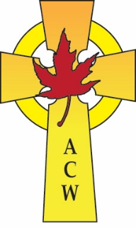
Anglican Church Women

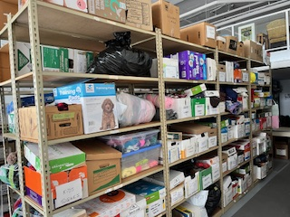
What is ACW Place???
Who is ACW???

What goes into a bale???
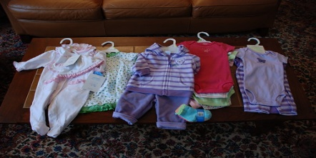

This Photo by Unknown Author is licensed under CC BY

Join us Saturday, June 13th 1:00-3:00pm
# 3 – 6678 – 152nd street Surrey (Hyland Square, enter Parking lot off 66A & 152A)


Come see what we’re all about!
Tour the warehouse
Meet the new secretary, treasurer and VP our chaplain & more board directors
Make new friends & enjoy a cup of tea
This Photo by Unknown Author is licensed under CC BY-NC-ND
Christ Church, Hope

Will be holding their annual
Strawberry Tea on
Weds, June 17
From 1 PM to 3 PM

Christ Church also has a takeout
Strawberry Tea on the same day
done by preordering with pickup

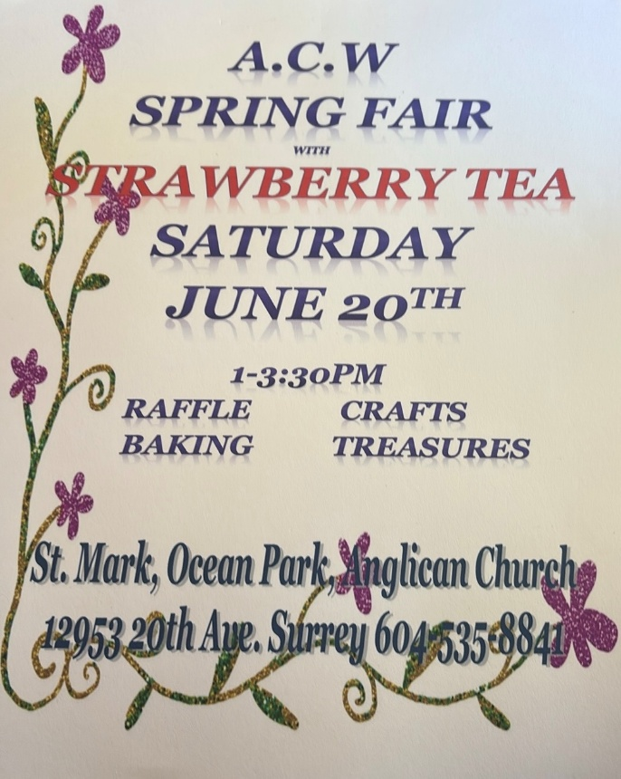

MEET YOUR NEW ANGLCAN CHURCH WOMEN BOARD OF DIRECTORS
Vice President Chris Longley
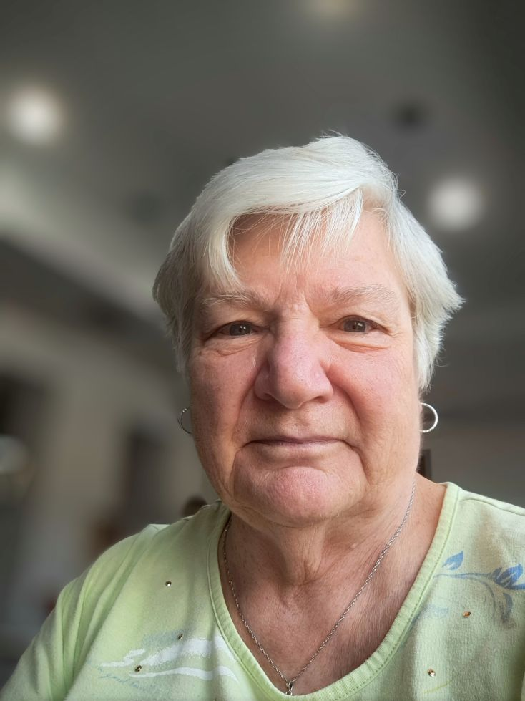
I grew up in England, emigrating to Canada when I was 20 years old. I lived in Halifax NS for 2 years and it was there that I was baptized and confirmed into the Anglican Church. (In England I was raised as a Baptist but attended all my schooling at a Catholic convent). After 2 years on the east coast I decided to give the west coast a try and moved to Vancouver.
I initially worked in banking but transitioned to estate and trust work. I joined the Office of the Public Guardian and Trustee in 1974 and stayed with them until my retirement in 2009.
I was married in 1973 but sadly that relationship did not last, and I spent the next 20 years as a single parent. I joined an organization called Parents Without Partners (PWP) and held many board positions at the local and international levels, ending my time with them as Chairman of their International Board of Directors for 3 years. I left PWP to marry my long-time sweetheart, Geoff. Geoff and I raised three grandchildren following the death of Geoff's son. One of those boys still lives at my house, I call him my cellar-dweller!
I am an avid family history researcher and have taught many seminars; I am a Past President of the Abbotsford Genealogical Society and coordinate the PoCo Genealogy Group.
In my Church life, I was a member of St. Catherine's in PoCo (currently merged with St. Laurence, Coquitlam) and was People's Warden for three years. I studied EfM for 4 years, graduating in 2016 and also completed both Parish Development Leadership courses led by Bishop Melissa at VST. Pre-Covid, I led Wednesday Morning Prayer at St. Catherine’s, and this has now evolved into weekly Morning Prayer at my house and by Zoom, mainly with former parishioners of St. Catherine's.
I was widowed in August 2025 and find lots to do to fill my days.

"Is prayer your steering wheel or your spare tire?" ~ Corrie Ten Boom
Secretary Victoria Finley
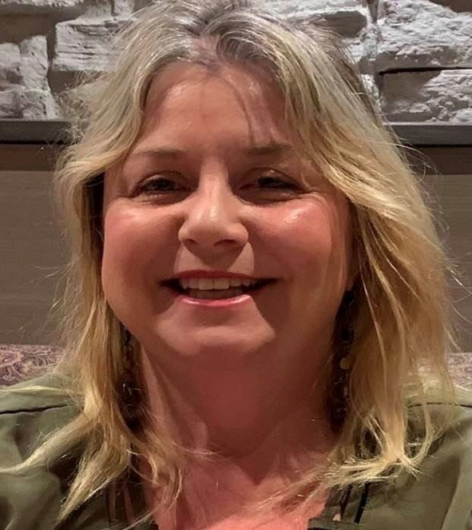
I am happy to serve as incoming Diocesan ACW Secretary. In the past, I have served as secretary for St Mark Ocean Park Parish Council and Valleyview Overlanders Lions Club of Kamloops, (now disbanded.) I am active on Altar Guild and the Counting team for St Mark Ocean Park. I particularly enjoy arranging flowers for the church.

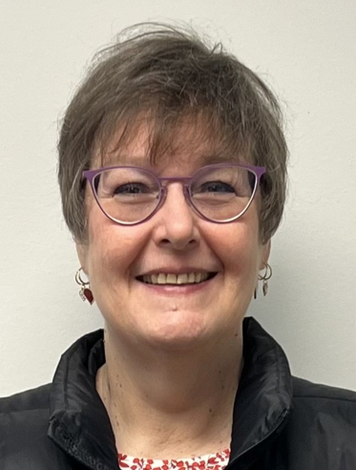
Treasurer Arlene Sturn
Arlene was born in Vancouver and raised in Burnaby. Although she has travelled extensively, touring Europe and living in London for 2 years as well as visiting Israel, Palestine and Egypt, she always returns to the Lower Mainland in the end.
She enjoys cross stitch, needlepoint, reading and playing the piano as pastimes. Arlene has always had an interest in alternative medicine due to chronic health issues so she studied medicinal herbs and became a chartered herbalist. In 2015, Arlene lived in Egypt in the Sinai for 6 months to continue to develop her knowledge of medicinal herbs. She made many life-long friends during her time there and, since she loves to travel, continues to visit whenever possible.
Arlene currently works for the Surrey School District as an AAC-SLP, supporting children with no voice. As a speech-language pathologist who has been in practice for over 35 years, she has a broad range of experience. She believes (rightly or wrongly) that running a small business for 30 years has given her the experience necessary to take on the position of Treasurer for the ACW DONW and appreciates the presence of a part time bookkeeper in supporting this belief.
Bookkeeper Athalia Lalwet
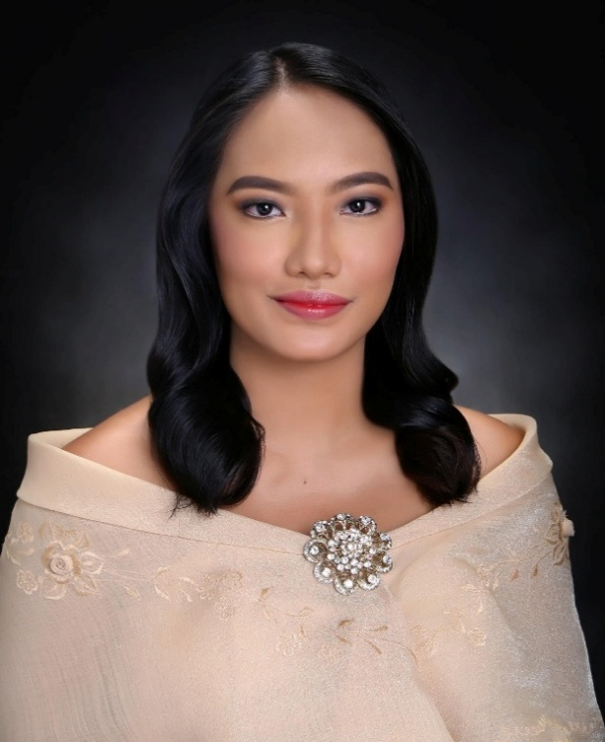
My name is Athalia Lalwet, and I am very grateful and excited to be joining the ACW team as the bookkeeper. I recently completed my Master of Business Administration degree and have previous experience in accounting and administrative support, including working as an Accounting Staff member for the Episcopal Church in the Philippines Pension Fund Office. I have also worked in hospitality and customer service, experiences that helped me develop strong organizational skills, attention to detail, and a passion for serving and supporting others.
The Anglican/Episcopal Church has always been a very important part of my life, as I was raised in a family deeply involved in church ministry and service. My father serves as the National Secretary of the Episcopal Church in the Philippines, while my mother is an active member of the Episcopal Church Women and has long been involved in church activities and outreach programs. Growing up in that environment gave me many opportunities to participate in church life and to witness the importance of faith, community, and service from an early age.
I am also an active member of Samahan ng Kabataang Episcopal (SKEP), the youth organization of the church, where I had the opportunity to be involved in youth leadership, organizing activities, and supporting church gatherings and programs. Through SKEP and other church ministries, I learned the value of teamwork, leadership, and building meaningful relationships within the community.
In addition, I volunteered with E-CARE, the community development program of the Episcopal Church in the Philippines, where I assisted in programs that supported farmers and local communities. Much of the work focused on helping farmers market and sell their produce more directly while reducing reliance on middlemen. Experiences like these showed me how the church’s mission extends beyond spiritual care and into community development, livelihood support, and social responsibility. I was also inspired to see the continued partnership between the Episcopal Church in the Philippines and the Anglican Church of Canada through Alongside Hope in supporting climate resilience and food security initiatives for communities in the Philippines.
Originally from the Philippines, I moved to Canada as an international student and have since
made Vancouver my home. I truly value the sense of fellowship, compassion, and service that
church organizations provide, and I feel very blessed to have the opportunity to continue serving
and supporting the church community here through the ACW.

Outside of work, I enjoy spending time with family and friends, exploring new places and food,
and learning new things. I look forward to meeting everyone, getting to know the broader ACW
community, and working alongside all of you in supporting the mission and ministry of the
organization.

With Faith and Gratitude,
Athalia

St Mark Ocean Park
Sponsoring Children Through Compassion Canada.

St Mark Ocean Park ACW have been sponsoring children through Compassion Canada for many years. Compassion Canada has a motto of "releasing children from poverty in Jesus' name".

At the present time we are supporting a young lad called Francis. He has progressed from playing games, dancing, playing a guitar and spending time with his friends into a young man seriously thinking of achieving goals that were previously impossible for him to attain.

His last letter to us was so very poignant and we were deeply moved by his words. He wanted us to know that he deeply appreciated our unwavering support and generosity.

He said our sponsorship has been a transforming true force in his life. It enabled him to pursue an education, develop skills and it helped support his community. It helped him to overcome challenges and obstacles.

Our support will help him to reach his goals. His goal is to become a good person and to excel in Technology while also allowing him to pursue his love of music. He said he was doing "really good" in Computer Science, and he was moving up a step to his goal.

He felt our amazing faith that we have shown him when we came to his rescue saved him. He felt that we trusted him when we didn't wait to see him face to face. We may not understand the depth of what we did for him and he said that we saved his life and introduced him to a gift of eternal life. We introduced him to peace and now he feels he has a future to look forward to.

He thanked us for the gift we sent to him, and he wanted us to know that he really appreciated it.

His letter was deeply moving and touched our hearts. We thank GOD that we were able to make a difference in this young man's life.

We would like to encourage other ACW's to seriously think of sponsoring children and giving them an opportunity that will change their lives.

We started sponsoring Francis when he was eighteen years old. Our previous child that we sponsored came to us before he went to school and we continued sponsoring him until he graduated from school. This is our third year with Francis.

I have enclosed two pictures of Francis. The first picture is when he proudly shows us how he decided to spend his birthday money when he was nineteen. He bought himself a school bag, four bars of soap, a pair of shoes, sports wear and sweets. The second picture was taken at his August 13, 2025, birthday. He was very happy with the two school uniforms for Advanced Level and some sweets.

Respectfully submitted, ( Editor: Unfortunately, the pictures did not copy)
Joyce McQuarrie

EVER CONSIDERED HOSTING A DIOCESAN ACW

FALL GATHERING OR AGM??

This could be a perfect way to meet your fellow ACW members from across the Diocese
AND encourage other ladies within your own parish to want to learn more about the
long and dedicated history of the ANGLICAN CHURCH WOMEN.
Perhaps, you might say ‘we don’t have the woman-power’ or hall or parking to take on
such an event. This is something your Diocesan ACW Board has been discussing.
Why not consider ‘sharing’ the responsibilities with another parish? You may be able to
provide a meeting or worship space if someone else is willing to host morning coffee
and/or lunch?
By sharing, you may find some portion of hosting works for the talents of your group.
Some are blessed with baking skills (ie muffins, scones for morning coffee), others with
organizational skills (planning a lunch menu or contacting a caterer) and others in
working with your parish priest and organist in planning a worship service.
Throughout this process, you will be supported by the experience and knowledge of
your Diocesan Board.
Sharing responsibilities and working together is a recipe for success.
As women of faith, we are called to serve. Please ask the ladies (current ACW
members or not) of your parish if the Spirit is calling them to share their gifts and
welcome their sisters in Christ to a time of fellowship, worship and learning.
Please contact our Diocesan ACW President, Kelly Bowman, for further details.


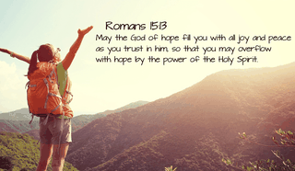

2026 - 2027
NEW WESTMINSTER DIOCESAN BOARD

President: Kelly Bowman, acw.kelly@gmail.com
Vice President: Chris Longley, cwilli2442@aql.com
Secretary: Victoria Finley, secretaryacw@gmail.com
Treasurer: Arlene Sturn, acwtreas@gmail.com
Past President: Gail Revitt, revittgail@gmail.com
~~~~~~~~~~~~~~~~~~~~~~~~~~~~~~~~~~~~~~~~~~~~~~~~~~~~~
Members
At Large: Ann Blue, blueann@shaw.ca
At Large: Dinali Fernando, defonsekad@gmail.com
At Large: Brigitte Laweng, rbusaing@shaw.ca
At Large: Joyce McQuarrie, joycemcq2@gmail.com
SW Fraser Rep: Judy Nicholson, bnichols@dccnet.com
At Large: Susan Williams, sjwrmt@gmail.com
~~~~~~~~~~~~~~~~~~~~~~~~~~~~~~~~~~~~~~~~~~~~~~~~~~~~~
Appointed Assistants
Chaplain: Reverend Mother Miranda Sutherland
allsaintsinchrist@gmail.com
Calendars: Sylvia Enga, sylviaanneenga@gmail.com
Membership: Dinali Fernando, defonsekad@gmail.com
Memorial Roll: Joyce McQuarrie, joycemcq2@gmail.com
Newsletter: Gail Revitt
Social Action: Beth Fortin, rcee99@hotmail.com

