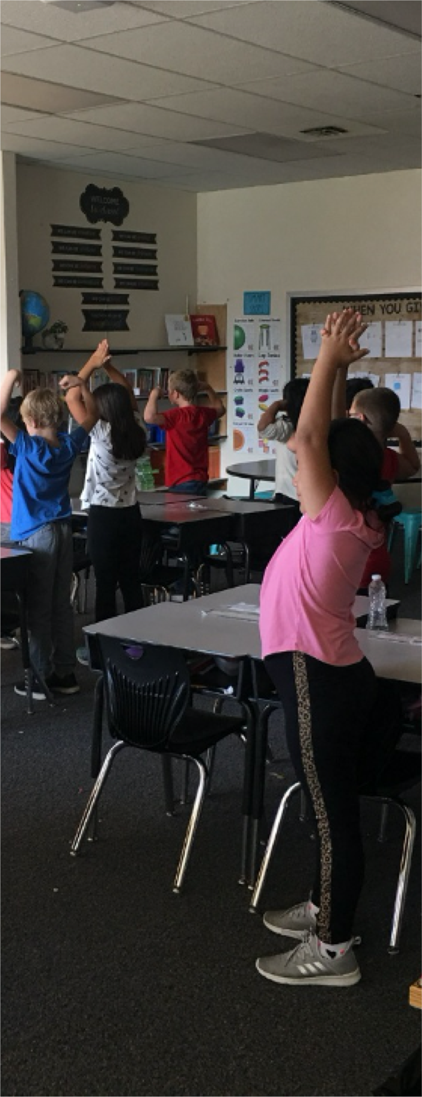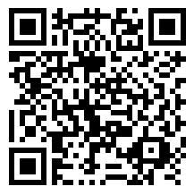BEPA 2.0 TRAINING
BE Physically Active 2Day!
BEPA 2.0 is a school-based physical activity ”brain boost” program aligned to state physical education (PE) and health education standards.
This training is designed for elementary-level educators and enrichment program providers.
BEPA 2.0 can be used to deliver activity brain boosts and to provide PE minutes for your students as required by ORS329.496.
The training consists of two parts:
- Online, asynchronous training material to be completed at your own pace.
- A 90-minute follow-up training via Zoom, led by BEPA 2.0 program director and Oregon Department of Education (ODE) staff. Participants can pick the follow-up training time that best fits their schedule.

April 5, 2022 from 4:00 – 5:30pm
or

April 28, 2022 from 4:00 – 5:30pm

The first 50 registrants will receive a BEPA 2.0 Toolkit for FREE. The training also provides three hours of professional development time that can be completed on your own schedule.

Scan the QR code or visit the link below to complete your pre-registration and be sent a discount code to sign up for the training at no cost to you.

https://oregonstate.qualtrics.com/jfe/form/SV_bsBiDbAMQomFgvY
REGISTER ONLINE TODAY

