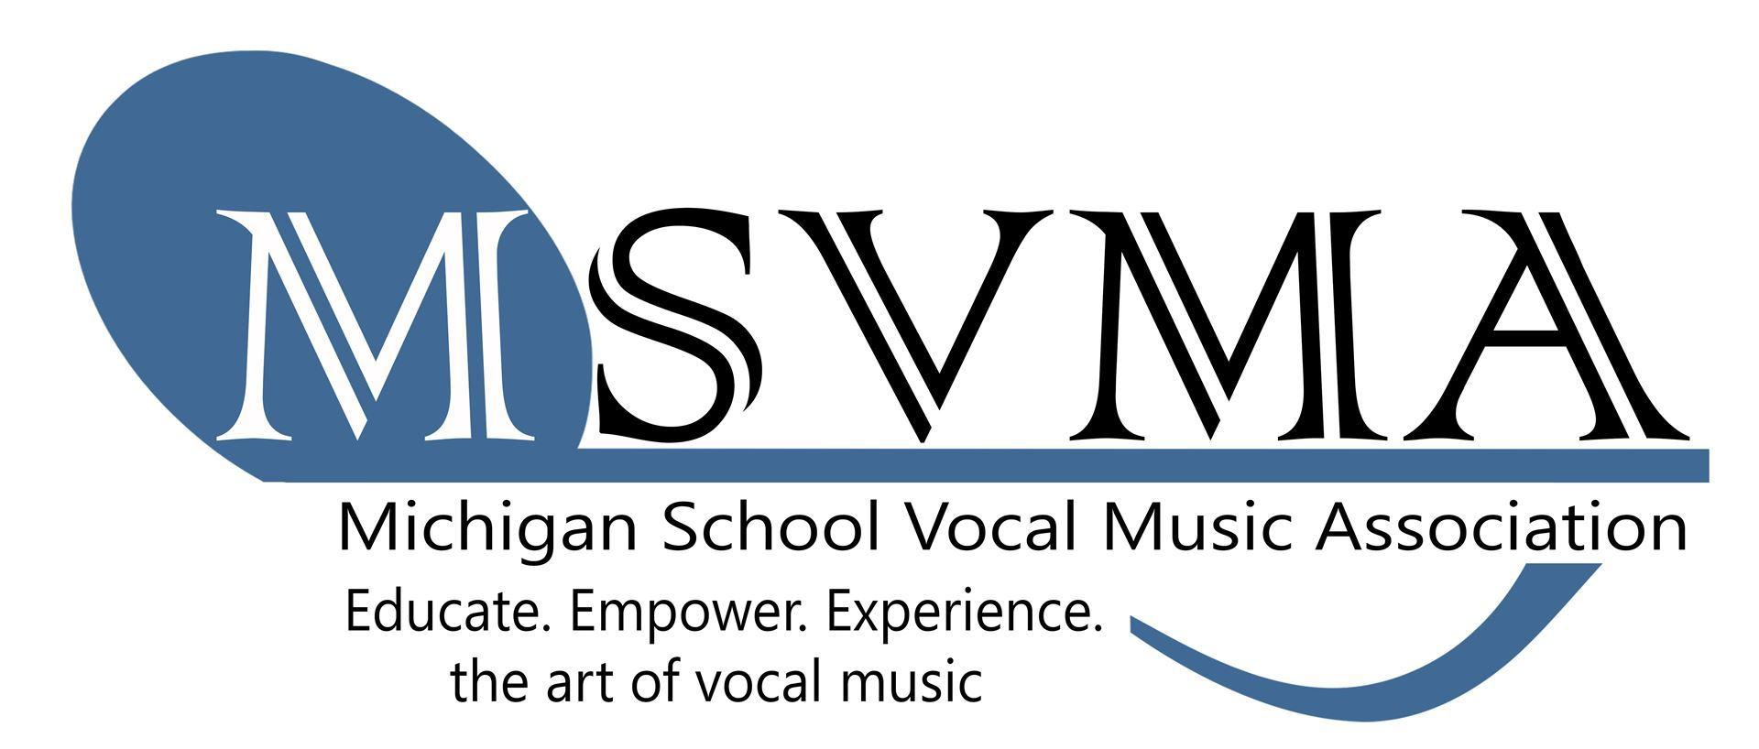
MSVMA Scheduling Website
Choral Festival Registration

On the Choral Festival page of the MSVMA website click on the registration button, or click here. Enter your username, which is the same email that you use to log into MSVMA.org, and your password for the scheduling website.

- To register for Choral Festival, look to Member Tools in the left menu, and select the “Register for Festival” option.

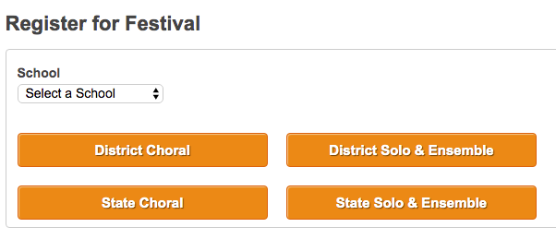
- From the dropdown list, select which school you will register for the festival, then choose “District Choral.” If you have more than one school, be sure to come back and do this again for your second school.

- On the next screen, select a festival from the available options in the “select a festival” dropdown. Only festivals open to registration for the previously specified school will display.

- At any time during the next several steps, you can “Save & Exit” which will keep that partially completed registration in your Choral Registration History in the main menu. Simply hit edit on that event to pick up where you left off.

- Enter Ensemble details on the first “Edit Festival Registration” screen.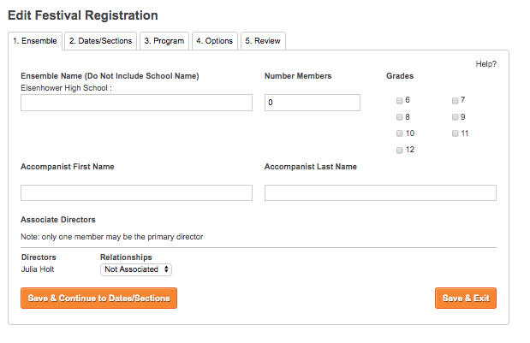

- If your district has multiple dates or sites, you will select your primary and secondary choices on the next page of the registration.
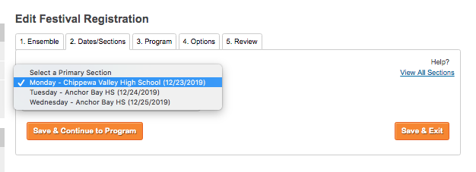

- The next page of registration is where you will enter your repertoire. Enter the title, composer, and voicing of each of your selections. (There is no longer a required list link to autofill the first selection.) If you are unsure at the time of registration, you can click those boxes instead of entering the titles – you will then need to edit your entry one week before the first day of the festival to include the actual repertoire that you are performing.

Next, enter your sight reading voicing - this must match the voicing of one of your selections. The voicings available match what is offered for MS/JH or HS choirs depending on which you are registering, so make sure you are registering each choir under the correct school if you have more than one school yourself. You can then choose your level: primary, intermediate, or advanced.
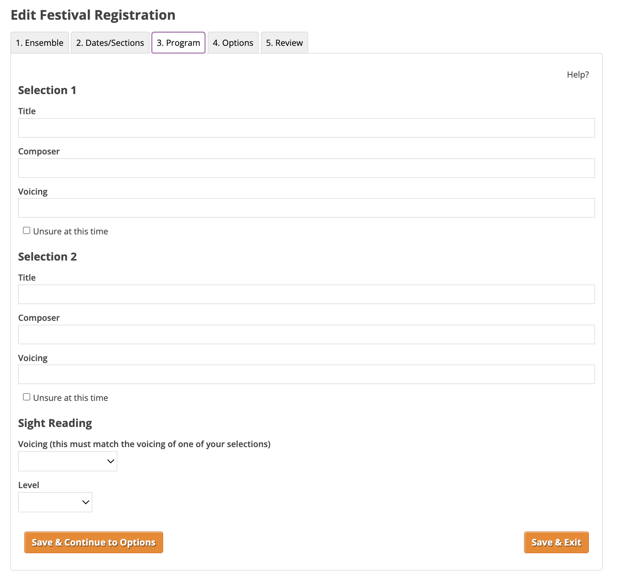
- Options tab – specify any special requests or needs for your group. Please realize that time preference is just that, a preference, and not all requests can be accommodated. There is also a spot to indicate any information you would like to share with the adjudicators about your group.

- On the final “Review” page of the registration it will show all the information you have added. If everything looks good, click on the “Register” button to complete the registration for that event.

- To generate an invoice:

  - Select “My Invoices” from the Member Tools menu.
  - The results will include a description, appropriate school, cost, and a “Generate Invoice” button.
  - If you have multiple choirs that are all on separate invoices, you can click the checkbox to the left of each entry and then click the “Combine Selected Invoice Items” box at the top of the list. This will put all entries into one invoice.

- Click the box to certify that the students that you are registering are in good standing in the vocal music program at the school for which they are registered.

- Click the box to certify that you have secured the appropriate number of copyright compliant scores for your events.

- Choose whether you would like to pay by check or by credit card.

- Once the invoice is generated, there is a “Print Invoice” button at the top of the page. You no longer need to collect signatures or mail your invoice to complete your registration. If you paid by card, you will automatically be marked as paid in the system and you are all set. If you are paying with a PO or check you will need to mail that to the address on the invoice. It is helpful to include a copy of the invoice with your payment, but is not required.

- At any time, you can choose the “View Invoice” button on your “My Invoices” page to see the full invoice or reprint.

- You may edit repertoire by going to your Choral Registration History, clicking the edit button next to the appropriate event, and selecting the “Program” tab. This will not be available once you are within one week of the first day of your festival.

