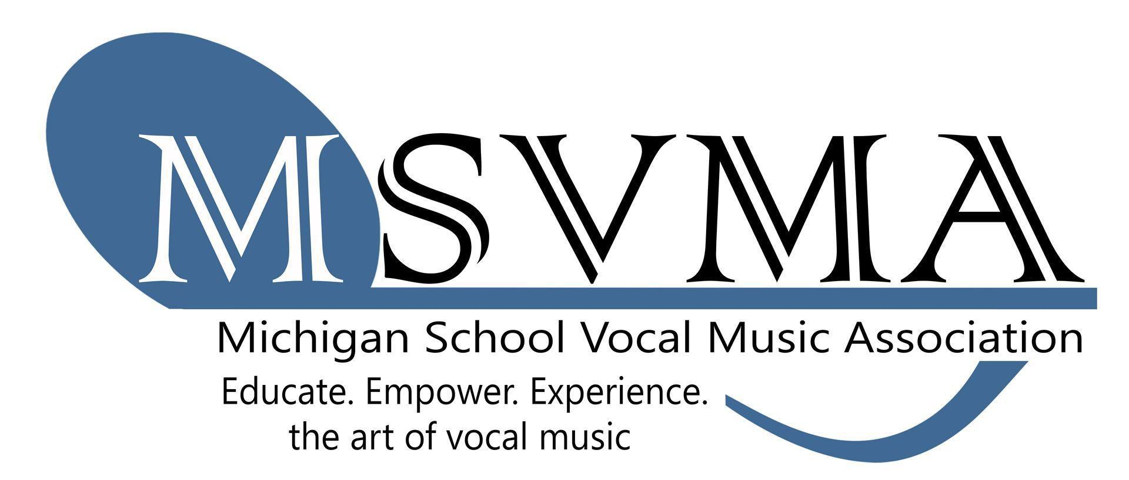
MSVMA Scheduling Website
Welcome Information
Updated 09.09.25

Here are some important things to note about setting up your profile on the MSVMA Scheduling Website:

- To get started, go to our scheduling website here.

- Log in with your email for the username—whichever email address is currently on file with MSVMA. For your password:

  - Members new to the scheduler should use the generic password: Msvma123
  - Returning members use the password previously used on the site. If you do not remember your password, there is a reset link on the login page.

- If you have trouble logging in, please call the State Office or email debrajacks@msvma.org.

8 AM - 4 PM - Monday - Friday
Closed Fridays - May 31 - August 30
231.592.9344

- If you cannot see your school information, it may be because your membership has not yet been renewed. Contact the State Office if you believe this is an error.

- Once you login, change your password by going to the “Change Password” link on the main left menu.

- You may now register for available festivals. Directions will be sent from your District Manager when they open registration and can also be found on the event pages of our website - msvma.org.

- Instructions can be found on the event pages on the website; Please read all instructions for the registration process before sending any questions. We are, of course, happy to help!

Happy registering!

