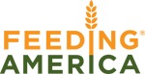
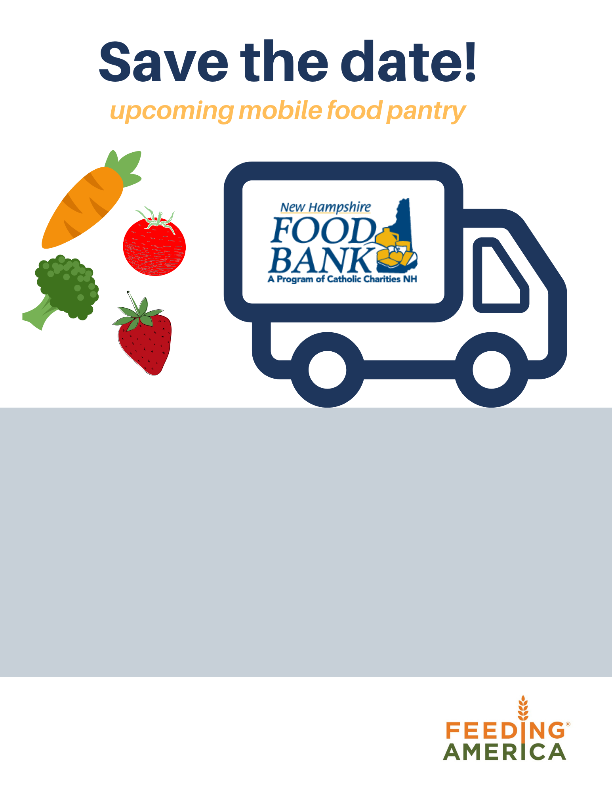

Fri, December 6th from 12:00-2:00
(While supplies last)

Runnings
403 Washington St., Claremont

The NH Food Bank will bring a truckload of food to distribute to families and individuals.

No proof of income or residence is needed. This is a drive thru event. All items will be distributed to you in your vehicles.

Sponsored by: Caring Neighbors

