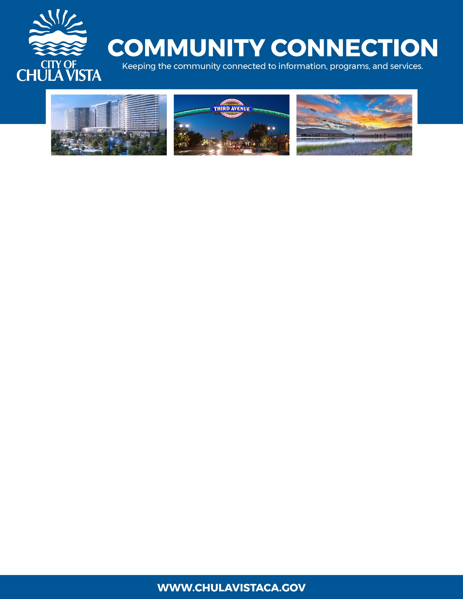
JUNE 2023

60th Annual Chula Vista Starlight Parade & Festival Returns on Dec. 14

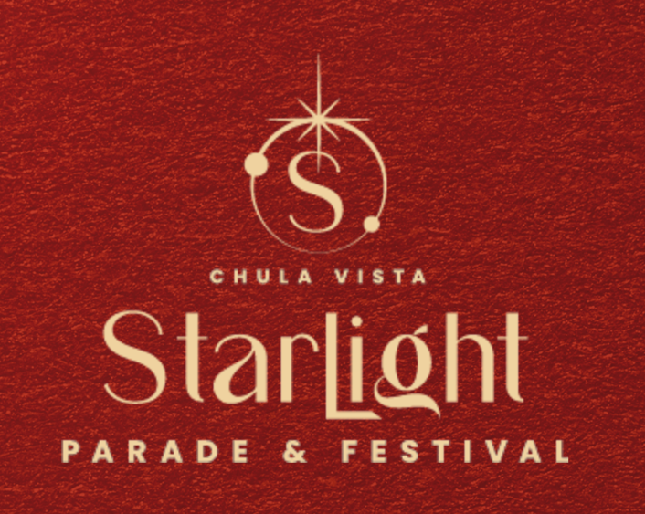
Mark your calendars, rally your crew, and get ready to soak in the sparkly splendor of the holidays because the Chula Vista Starlight Parade & Festival is coming back to Downtown Chula Vista for its 60th edition! This dazzling event had a triumphant return in 2023 after a three-year hiatus due to the pandemic, and this season’s festivities promise to shine even brighter and bring the community together to make memories and spread joy in unforgettable ways. Last year’s event was a runaway success, with a turnout of more than 50,000 guests that set a high bar for 2024, but Chula Vista is excited to elevate the experience this year.
“I’m excited to bring the Starlight Parade back again this year,” said Mayor and lifelong Chula Vista resident John McCann. “This is a historic Chula Vista tradition, a major part of our culture, and a way to unify our community. Growing up in Chula Vista, I participated in the parade as part of the Safety Patrol, and now my children and grandson have grown up attending the parade. We look forward to hosting a bigger and better parade and festival this holiday season.”
Downtown Chula Vista will come alive with snowflake lights and celebratory fun starting at 3 p.m. on Saturday, December 14. This exceptional event will include a holiday market selling gifts and treats from local artisanal vendors, and free photos with Santa available. There will be show-stopping live music and entertainment programming throughout the day, as well as arts and crafts for all ages.
A tree lighting ceremony is scheduled to begin at 5:45 p.m., with a holiday tree standing more than 25 feet - you won’t want to miss it! The ceremony kicks off the parade, which starts at 6 p.m. and will feature participants ranging from festive floats and marching bands to dance teams and classic cars. This year will also include new offerings, like a holiday movie screening at Memorial Bowl Amphitheater in Memorial Park, a larger stage for performers and presenters, and a Kids’ Zone with expanded activities.
The Chula Vista Starlight Parade & Festival would not be possible without our sponsors and supporters, which help bring to life this beloved and long-standing tradition each year. To participate in the parade or holiday market, apply and register here. To volunteer or become a sponsor, fill out the form here.
So please join us at this signature South Bay event—decked out in your finest, of course!

