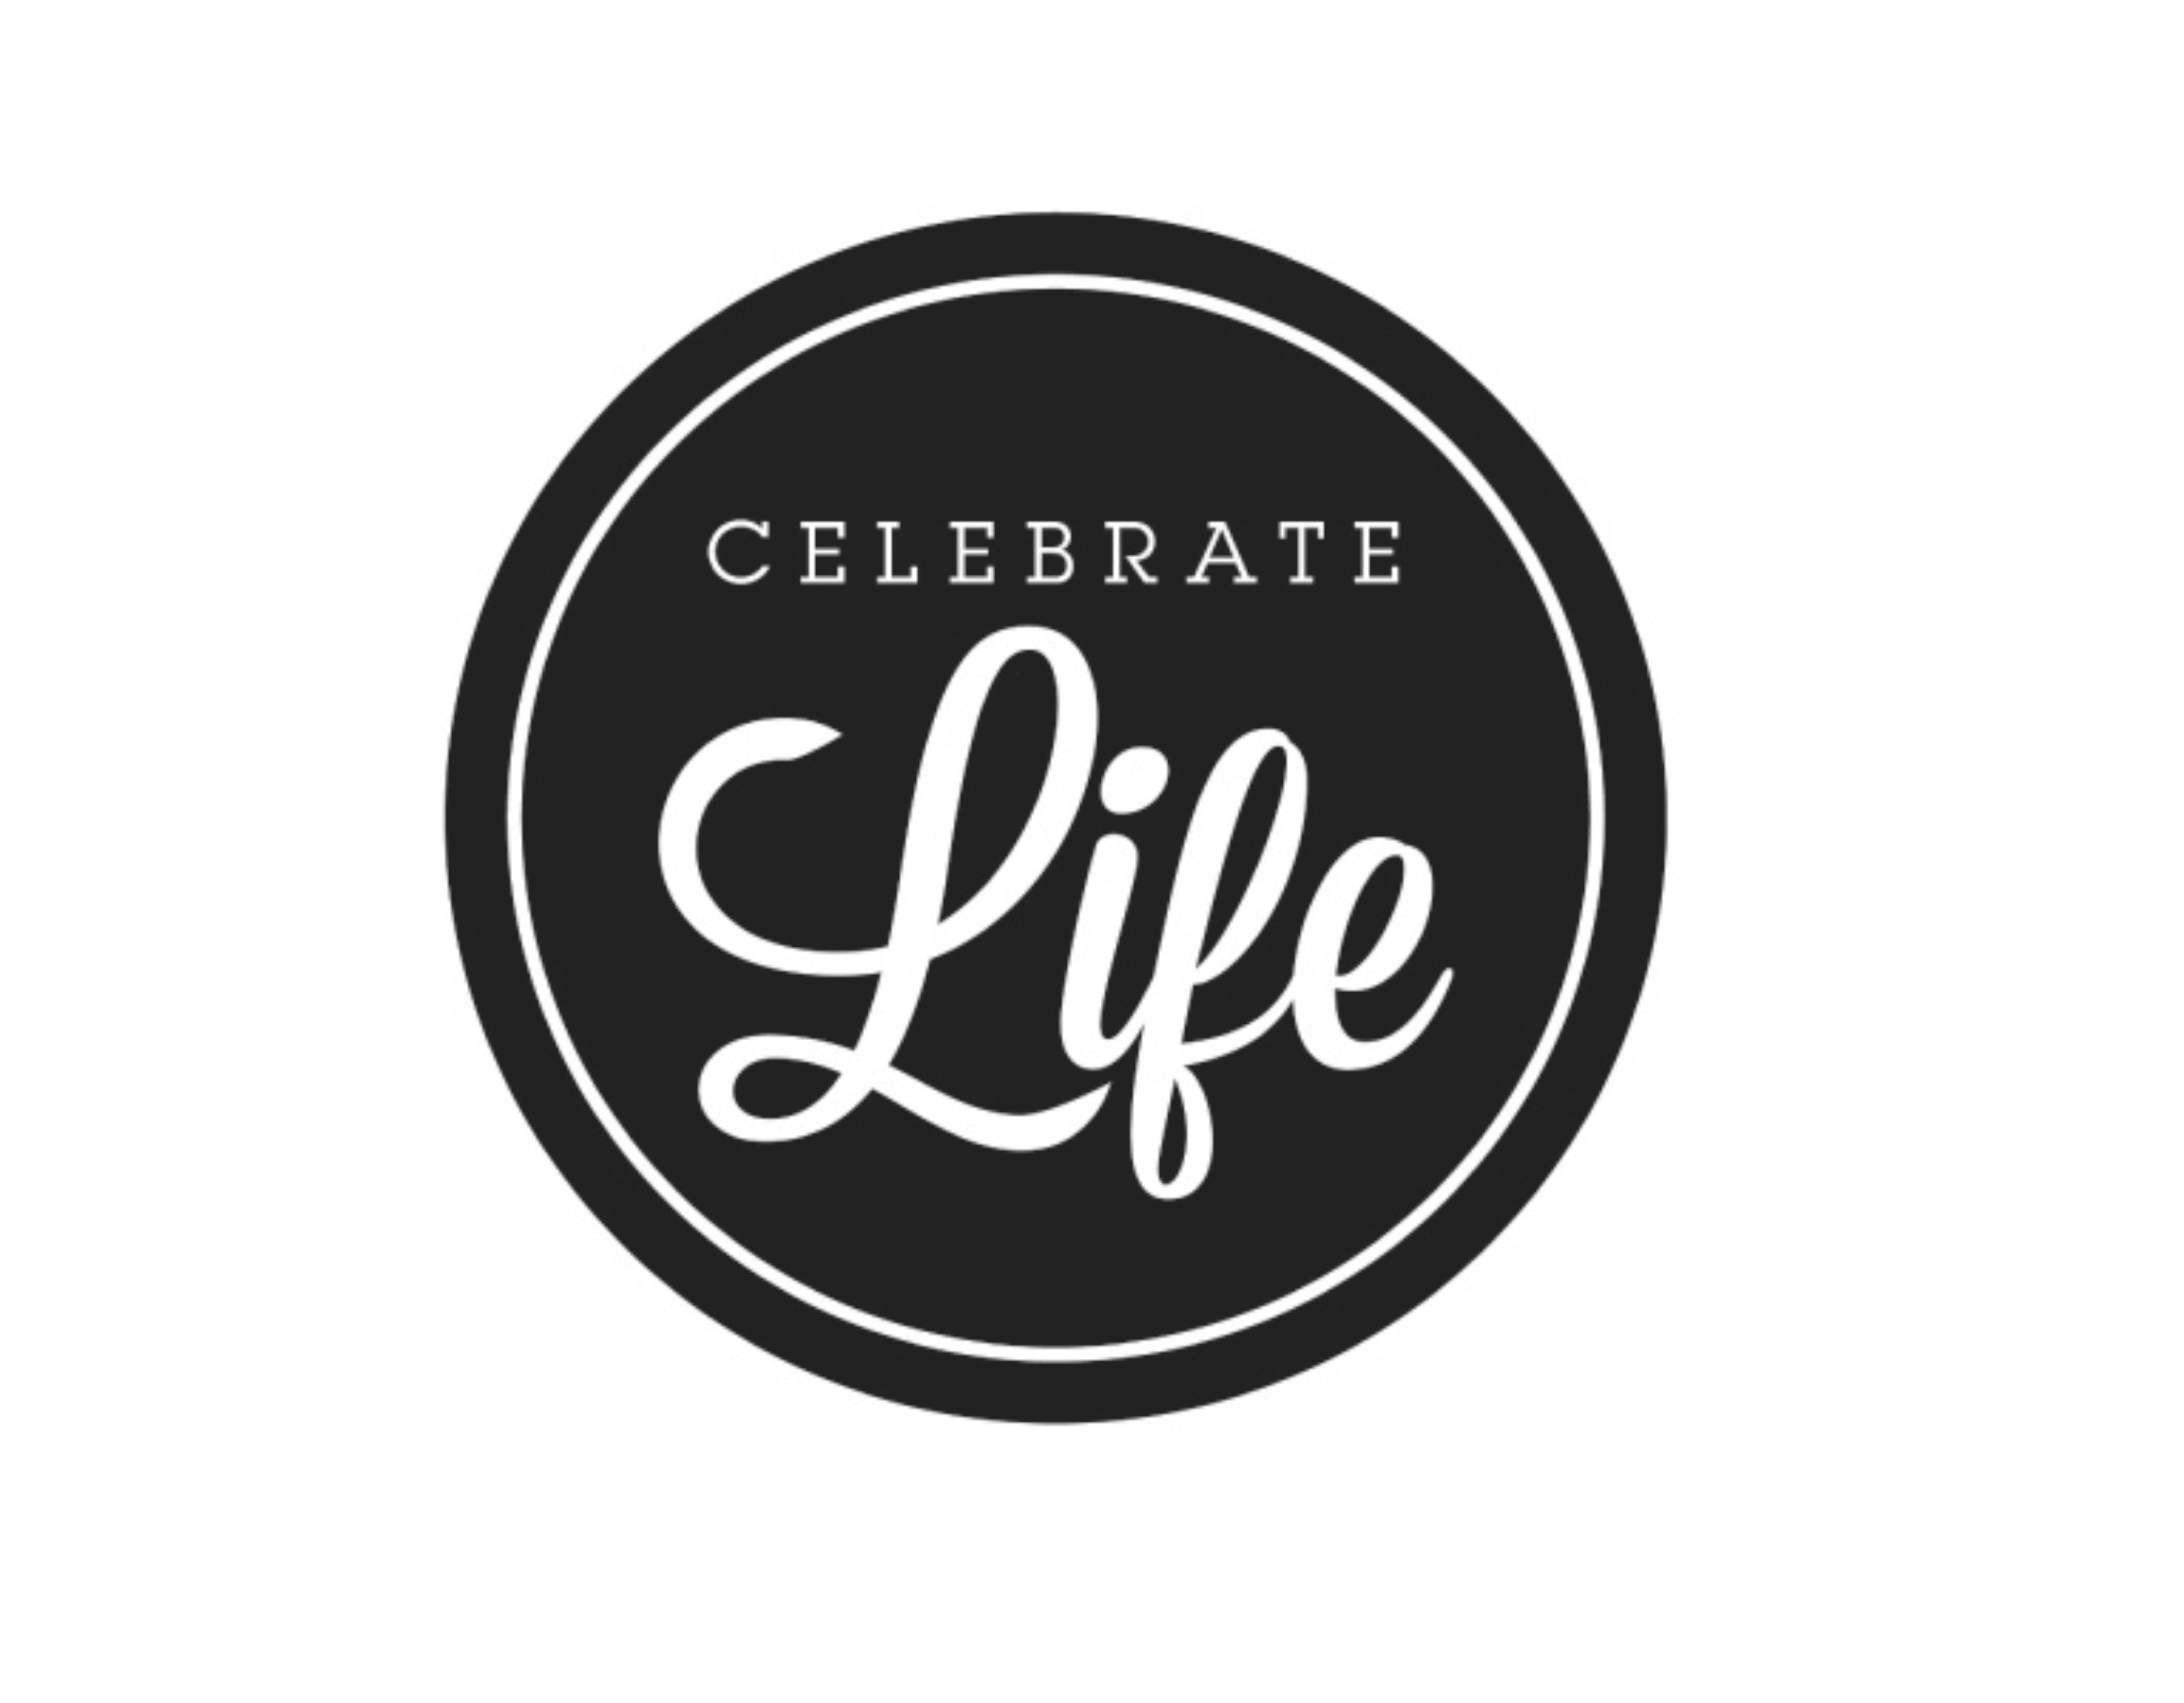

NWIL Allies ,

We are so excited about the upcoming Field Celebrate Life at ONU May 10-12, 2018. We are so happy that NWIL has so many students participating in Field Celebrate Life this year. Below is the process for registering. Please make sure that all participants that were chosen for a team can attend CL at ONU. If they cannot, please let us know by March 5. At that time we will contact the alternate. Reminder: This is event is for 7th-12th grade only!

Registration deadline: Friday, March 16
- Cost: $130 if postmarked on or before March 16
- Cost: $150 if postmarked after March 16

Registration Process:
1. Check personal/school calendars for availability to attend Celebrate Life @ ONU May 10-12.
2. Return registration forms to Kim Brock
3. Mail hard copy and payment on or before March 16 to:
Pekin First Church of the Nazarene
ATTN: Kim Brock
3514 Broadway Street
Pekin, IL 61554
Included in mailing:
- Hard copy of Registration Form/Permission Slip, Rock Climbing Waiver for each participant & sponsor (with all signatures)
- Copy of Insurance Card for each participant & sponsor (front & back)
- Sponsors must fill out a registration form/permission slip & waivers
- Payment of $130 per participant & sponsor (if postmarked by March 16)
- Check payable to: NWIL-NYI

Each church must provide the following ratio of sponsors to participants they send. We could not possibly have the quality Celebrate Life we want to provide or the safety needed if we do not have enough sponsors. The ratio is one sponsor per five participants. Please make sure to have the correct ratio of male & female sponsors for the participants your church is bringing.
Example: 8 male participants = 2 male sponsors, 11 female participants = 2 female sponsors
We realize some churches are smaller than others and may not be able to send a sponsor. We suggest that the churches on each zone get together and help each other with sponsor needs or contact your zone facilitator for assistants.

1-5 participant – ONE sponsor
6-10 participants – TWO sponsors
11-15 participants – THREE sponsors
16-20 participants – FOUR sponsors
20-25 participants – FIVE sponsors

If your church does not have the correct ratio of sponsors to participants, the Celebrate Life Director will contact you. If we do not have enough adult sponsors to cover the registered participants, the participants from churches failing to meet the participant to sponsor ratio will not be able to attend Celebrate Life.

All sponsors attending must stay on campus in the dorms for the entirety of the event. You are responsible for keeping track of your participants and making sure they are abiding by all rules and getting to all events in a timely manner.

**Please note the time change for registration**
Celebrate Life begins with registration at 8:30-9:45am for NWIL ALLIES in the Centennial Chapel on Thursday, May 10, 2018. Please have all participants registered and items in their room by 9:45 am. There will be a District Huddle at 10:00 am in Centennial Chapel. Please gather at the NWIL table. An opening ceremony will follow and begin promptly at 10:30 am. Late registrants may proceed to the Tiger Den following the opening ceremony.

Please have all participants registered and items in their room by 9:45 am. There will be a District Huddle at 10:00 am in Centennial Chapel. Please gather at the NWIL table.

Celebrate Life will conclude at 12:30 P.M. on Saturday, May 12, 2018.

Thank you for all your help to get your students to Field Celebrate Life 2018. Contact us with any questions.

In Christ,
Pastor Kim Brock Pamela Smith
Celebrate Life Director Celebrate Life Co-Director
redheadkim@aol.com nwilpamsmith@gmail.com
309-346-3053 (chuch office) 309-682-6945 (district office)
309-231-5875 (cell) 309-208-7595 (cell)

**Field Celebrate Life at ONU May 10-12, 2018
THURSDAY
Registration: 8:30am-9:45am Centennial Chapel (locate the NWIL table)
Please have all participants registered and items in their room by 9:45 am. There will be a District Huddle at 10:00 am in Centennial Chapel. Please gather at the NWIL table.
Opening Service: 10:30am-11:30am Centennial Chapel
Break Out Sessions: 11:30am-12:30pm (Mandatory)
Lunch: 12:30pm-2:30pm
Competition starts: 2:00pm
MARK YOUR CALENDARS
Field Celebrate Life @ ONU
May 16-18, 2019
May 14-16, 2020

