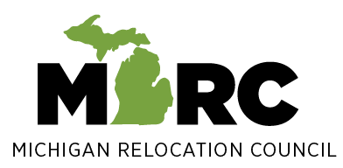

Michigan Relocation Council (MiRC)
2025 Scholarship Application

Application must be received by MiRC no later than March 1, 2025 (No exceptions, please). Please refer to the MiRC Scholarship Instructions for Students for more details about the scholarship and submission guidelines.
We 7201
Student Name:
Parent(s) Name:
Home Address:
Home (or Parent’s) Telephone:
(Applicant’s) E-mail:
(Parent’s) E-mail:
High School:
Month/Year moved to or within Michigan:
Relocated to Michigan from (City/State):

I certify that the essay that I am submitting with this application is entirely my own and that the information I have provided on and with this application is true to the best of my knowledge.

Student Signature______________________________________ Date______________________

Section below to be completed by Guidance Department or High School official:

Please include a copy of transcripts/test scores with the application and kindly complete the following:

Student Grade Point Average__________________ Grade Point Average Scale__________________

Student’s Most Recent Test Scores (SAT, etc.)_____________________________________________

Your Name (printed) _____________________________ Title___________________________

Your Phone ______________________________ Your E-mail _____________________________

Your Signature__________________________________ Date___________________________

