The WGS Control Warehouse Retired to Archive

The original WCCS Control Warehouse has evolved over the past 27 years. It has now moved to a static archive.
The move to retire the records to a static archive is the end of a legacy of the control warehouse initiative, begun in 1995. Spearheaded by WADNR, Pierce, King and Snohomish Counties, a team of volunteers developed a generic control record report for MS Access that was adopted by many counties, cities, and agencies to document their own survey control with a standard report for internal uses and/or public access.

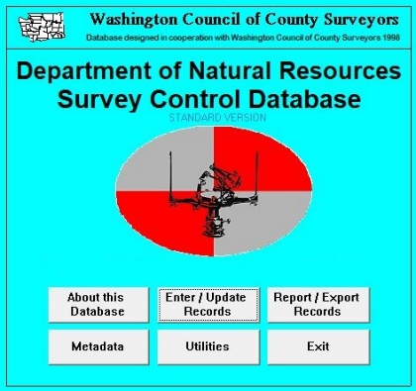
The generic database template, developed in 1996, was produced in several formats, wit the most commonly adopted being an MS-Access Database that cities, counties, and agencies could customize to hold their control records for upload into the online web portal.

Soon after, the Washington Council of County Surveyors sponsored a web map interface that accessed multiple databases of the various entities the used generic control record template. This was known as the ‘WCCS Survey Control Warehouse’. The web map interface was upgraded several times, with the most recent iteration sponsored by the non-profit Washington Geodetic Survey, with the web map interface known as ‘GSOW’.

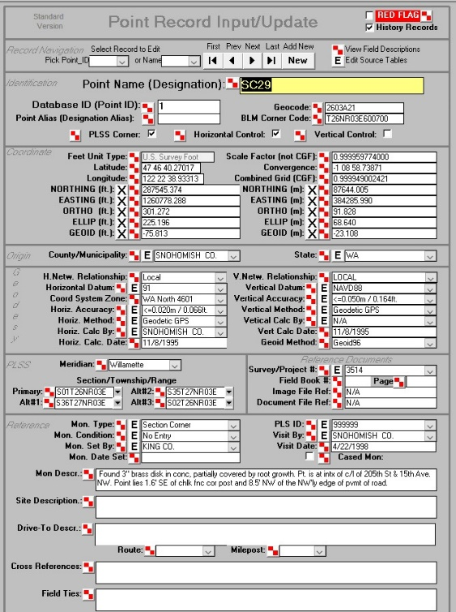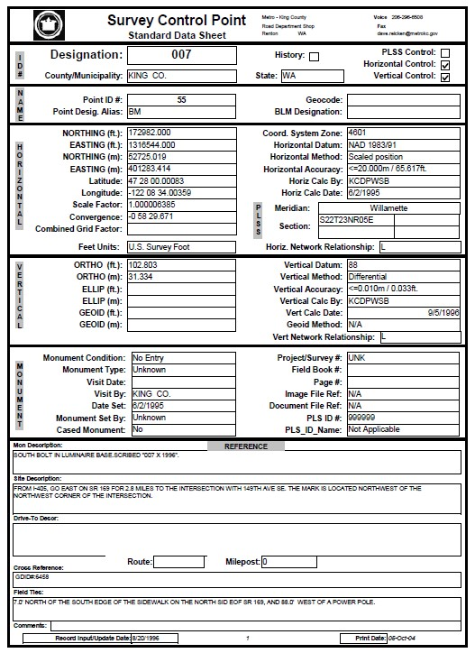
The generic database had tools to import and export delimited text files, and cutomizable input form, and standard report outputs. The report format remained standard throughtout each redesing of the web portal, and several justridictions have adapted it for their new databases.

In recent years, many of the participating entities have chosen to withdraw as they did not want obsolete reports circulating, and many do not have budget to keep all records up to date. The conventional wisdom on keeping control databases has changed somewhat. With the advent of high-precision GNSS, reliance on legacy control records has not been a priority for many entities. And with the best practice of independent verification of any control and records used, legacy databases were viewed by some participating entities as being of questionable value, other than helping someone find an old mark. Many participating entities view the obsolete coordinates as being of no value beyond temporal comparison or coarse mark searches.

As the latest web map interface was also facing obsolescence, the WGS decided not to redesign, but instead to decommission the interactive database and preserve the old records as a static archive. The records were archived on July 1st, 2020, and the legacy web interface decommissioned on January 1st, 2022.

The records are PDF copies of reports generated from the legacy WGS control warehouse and are presented “as is”. The Washington Geodetic Survey, the Washington Council of County Surveyors, and any agency, individual, or company listed on any records in this archive ACCEPTS NO RESPONSIBILITY FOR THE ACCURACY, CURRENCY, OR COMPLETENESS OF THIS INFORMATION. For additional information, contact the database steward of the specific record. Any coordinates listed are for general location purposes only and do NOT imply any accuracy or specificity of the monument location.

Via the link below to the archive Google Drive folder, you can download any, or all, of the individual reports, and several spatial format index files:
wgsarchive.org

If you are seeking updated control records you will need to contact various cities, counties, and agencies directly. Example: The City of Seattle has put tis vertical control database online at: www.seattle.gov/utilities/construction-resources/land-surveys/survey-data
​
The control warehouse was cutting edge in 1996 and provided a valuable service to the participating entities that may have not had any other way to disseminate their control records via the web. Plus, per the goals of the original WADNR initiative, it provided a consistency in the type of control reports surveyors would get from multiple jurisdictions. It was also one of the first truly cooperative control warehouses operating online anywhere. But times and technology change. There are too many people to thank individually. Those who volunteered to keep this 25+ year initiative going should be proud of what was accomplished.

