After many years of focusing her art practice on the creation of commissioned liturgical projects, artist Linda Witte Henke is now pleased to offer seasonal liturgical collections of visual resources as a GIFT to the church.
Click HERE for an overview of the Lent Year B collection.
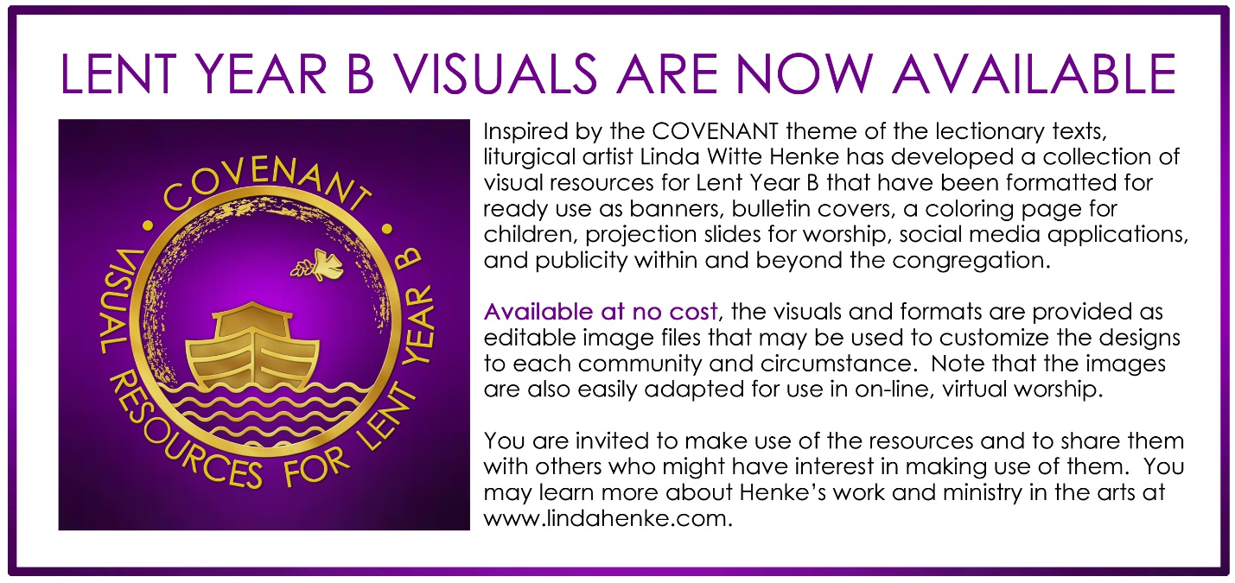
Click HERE to access the Lent Year B editable images.

For reference in verifying the above links:
OVERVIEW LINK: https://www.dropbox.com/sh/j21vgjfwvfbg54t/AADnkISVsdYFWzFAricv3POMa?dl=0
LINK TO EDITABLE IMAGE FILES: https://www.dropbox.com/home/0%20-%20Linda%20W.%20Henke%20-%20IN%20DUE%20SEASON%20-%20Years%20A%2C%20B%2C%20C/YEAR%20B%20-%20LENT

