PIONEER DAYS LITTLE MISS & MASTER PAGEANT
WEDNESDAY, OCTOBER 17, 2018 6:00PM
LOCATION: ELKS LODGE #2134, TWENTYNINE PALMS, CA 92277
APPLICATION DEADLINE: OCTOBER 6, 2018 BY 2:00PM
LIMITED TO THE FIRST 20 ENTRANTS!
AGES 4-7.

Contestant Name: ______________________________________________________________________
Age: ____________________ DOB: _____________________ Phone Number: _____________________
Address: _____________________________________________________________________________
Email Address: ________________________________________________________________________
Guardian Name: _______________________________________________________________________
Sponsor: _____________________________________________________________________________
List three items of interest to be used as questions for your child. (School, books, pets, hobbies, siblings, talents, nicknames, etc.)
- ____________________________________________________________________________________________________________________________________________________________
- ____________________________________________________________________________________________________________________________________________________________
- ____________________________________________________________________________________________________________________________________________________________

PAID: _________ Payment Method: ____________
Amount Paid: $__________ CoC Initials: ______

** There will be REHEARSALS, OCTOBER 6, 2018 ON CHILDREN’S DAY AT THE HEALTH FAIR AT LUCKIE PARK ON A BIG STAGE. STARTING AT 10AM-2PM, GOING EVERY HALF HOUR**
RULES:
- Entry fee for all participants is $30.00 per entry. All entry fees must be paid at the time of registration.
- Contestants must be at least four and no older than seven years on the day of the contest. Entry deadline is 2:00PM October 6, 2018. (first 20 entries will be accepted).
- Children are asked to dress In Frontier (past or future) inspired costumes. Contestants will be “interviewed” by the emcee using the information provided on the entry form. If the child possesses a particular talent please list it. All contestants will receive certificates and prizes for their participation. Along with a plaque with their picture for 1st, 2nd, and 3rd place. Each entry will get a sash with their sponsors name on it.
- Contestants are highly encourages to attend practice.
- The pageant will start at 6:00pm, Wednesday, October 17, 2018 at the Elks Lodge #2134, Twentynine Palms, CA.
- All contestants are invited to ride in the annual Pioneer Days Parade on Saturday, October 20th. Check in for the parade will be at 8:00AM, parade starts at 10:00AM. Please note that a parent or designated guardian, at least 18 years or older, must accompany each child. Information on where and when to meet will be provided to families at the dress rehearsal.
If you have any questions, contact Cora Heiser at (760) 819-1917 or email cjheiser@hotmail.com
Please READ AND INITIAL:
__________ Participants, by execution of this entry form, release and discharge all above sponsors, their members, agents, employees, volunteers and/or the employees, representatives and anyone else connected with the management or presentation of the Pioneer Days Parade, from and against all liability loss that the participants or entrants, guests including family and relatives, may sustain or incur as a result of any known or unknown damages, injuries, claims, demands, or judgements, arising from participants’ or entrants’ involvements in the October 20th, 2018 Pioneer Days Parade in Twentynine Palms, CA.
__________ I understand that at this event or related activities, I may be photographed. I agree to allow my photo, video, or film likeness to be used for any legitimate purpose by the event holders, producers, sponsors, organizers, and assigns, without any expectation or right to compensate.
Signature: __________________________________________ Date: ______________________
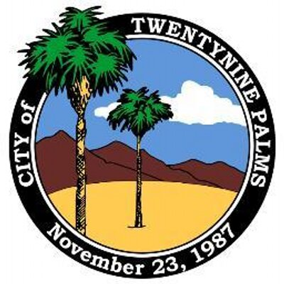
Please remit form to: Twentynine Palms Chamber of Commerce
73484 Twentynine Palms Highway
Twentynine Palms, CA 92277
29chamber@29chamber.org • www.29chamber.org

