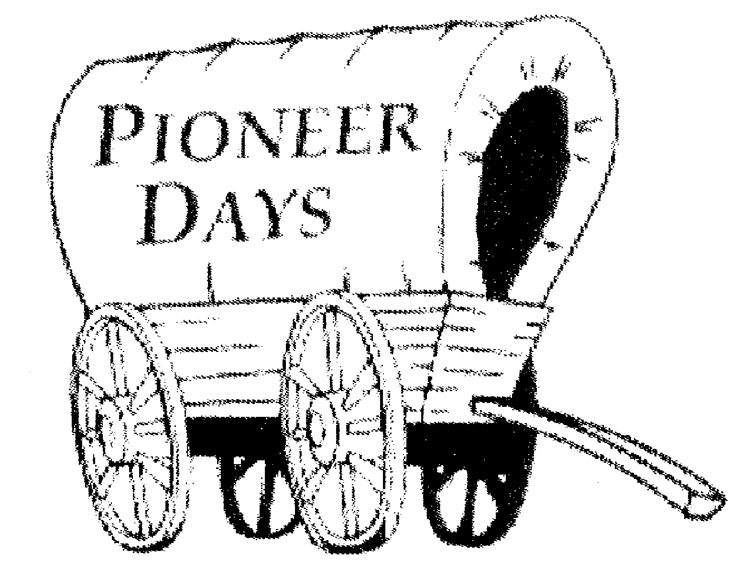
82nd Annual Pioneer Days
Judge & Sheriff Competition
“Ransom” Fee: $20.00 per team
Team Sponsor:__________________________________________________
Judge Contestant Nickname: ___________________________________________
Contestant Name (First & Last): ________________________________________
Address: ___________________________________________________________
Phone Number: _____________________________________________________
Email Address: _____________________________________________________

Sheriff Contestant Nickname: __________________________________________
Contestant Name (First & Last): _______________________________________
Address: __________________________________________________________
Phone Number: ____________________________________________________
Email Address: ____________________________________________________
Please remit form to the Twentynine Palms Chamber of Commerce
73484 Twentynine Palms Hwy, Twentynine Palms, CA 92277
PAID: Date___________Type of Payment:______________ COC Initials: ___________
Judge & Sheriff Competition
Rules and Regulations:
- All teams will consist of two people: one Judge and one Sheriff. All teams MUST have a team sponsor. Sponsors can be non-profits, churches, clubs, organizations, or local businesses. There is a limit of 8 teams.
- First place, Second, and Third place will be awarded a plaque that includes a picture of you in front of the jail, as well as bragging rights as the 2018 Judge & Sheriff. First place will be in the parade with the jail.
- Winners are determined by the number of buttons sold and/or monies collected. All buttons will be sold for $1.00 each. Sales will begin on October 6th, 2018 at the Children’s Day event at the Health Fair at Luckie Park, starting at 10AM.
- At the Children’s Day event, each team will be given 250 buttons. Your progress will be tracked online. Additional buttons can be picked up from the Chamber of Commerce office. In order to receive additional buttons, button sales monies must be deposited with Chamber of Commerce personnel. Candidates should retain receipts of deposit as proof of buttons sold.
- The contest will end at 8:00pm on October 19, 2018. All money collected and any unsold buttons need to be returned to the Chamber of Commerce by that time. Winners will be notified and announced publicly after a final tally by the contest coordinator and Chamber officials. Point of contact is Billie Flatter (760) -620-6535.
- In the event of a tie, the top two teams will be given any remaining buttons and 24 hours in a sudden-death duel! The team that sells the most buttons after the duel will be awarded the applicable “ransom” and dubbed Pioneer Days Judge & Sheriff.
- The official Pioneer Days Judge & Sheriff are encouraged to ride in the annual Parade on Saturday, October 20th, 2018 at 10:00am. Check in starts at 8am.
Both contestants Must Initial and Sign Below:
_______/_______ Participants, by execution of this entry form, release and discharge all sponsors, their members, agents, employees, volunteers and / or the employees, representatives and anyone else connected with the management or presentation of the 2018 Pioneer Days celebration, from and against all liability loss that the participants’ or entrants, guests including family and relatives, may sustain or incur as a result of any known or unknown damages, injuries, claims, demands, or judgements arising from participants’ or entrants’ involvement in the 2018 Pioneer Days celebration in Twentynine Palms, CA.
_______/_______ I understand that at this event or related activities, I may be photographed. I agree to allow my photo, video, or film likeness to be used for any legitimate purpose by the event holders, producers, sponsors, organizers, and assigns, without any expectation or right to compensation.
Signature:________________________________________________ Date:___________________
Signature:________________________________________________ Date:___________________

