Ohana Christian Fellowship of Seventh-day Adventists
Sabbath April 26, 2025

Sabbath School begins at 10 am

Children’s and Youth Sabbath School: Downstairs
Adult Sabbath School:
Library (Books of the Bible – Acts)
Fellowship hall (Lesson Study)

Church at Worship 11 am

Gathering Song Ohana Worship Team

Welcome & Announcements Eli and Hannah Franzke

Children’s Story Youth

Church Offering Karl Hare
“Oregon Youth”

Children’s C Praise & Prayer Ohana Worship Team

Message Message “Image” Dr. Ron Franzke

Closing Song
Benediction Dr. Ron Franzke

Sabbath ends today: 8:11 pm
Sabbath begins next Friday: 8:19 pm

Elders for the day: The Hares
Greeter: Theresa Powell
Deaconess: Louise Petersen
Deacon: Troy Wolf
WELCOME! We are so happy you joined us today.

Romans 8:29

“For those God foreknew he also predestined to be conformed to the image of his Son, that he might be the firstborn among many brothers and sisters.”

ANNOUNCEMENTS

FELLOWSHIP MEALS:
TODAY:
Haystacks (following church)
Miner’s home, 7825 Painter Loop Rd, Hubbard

NEXT SABBATH:
Breakfast, 9:00-9:45 am
No potluck after church
All are welcome to join us for great fellowship and good food.

OHANA: Interested in the goings on" at OHANA? Are you interested in what is going on at the church from a financial standpoint? How about from a church board standpoint? If you are, contact Pastor Doug to "have a look" on a more in-depth basis of what is happening at OHANA.

CAMP MEETING IS ON: Get ready for great messages, pronto pups, veggie burgers, fellowship and more. Camp meeting 2025 is a go! July 22-26. Ty Gibson is the main speaker. Don’t miss it!

BAPTISM TODAY AT MINER’S: You are invited to come celebrate with us as Laura Miner publicly declares her faith, and Ron Miner is rededicated through baptism! Don’t miss it! 17825 Painter Loop Rd, Hubbard.

OREGON MEN’S CHORUS CONCERT: You are invited to the OAMC annual spring concert on Sabbath, May 17, at 3:30 or 7pm, at Sunnyside Adventist Church. The “Praise the Name of the Lord” theme counts more than 50 names of God in the 13-song repertoire. Don’t miss it!

Nominating Committee is this Monday night
At 6:30pm at the church.

Praise Leader: Ryan Burville
Worship Coordinator: Anne Boutwell
Video: Trenton Gould
Sound: Ryan Boutwell
Pastor: Doug Franzke (971) 270-8423

Please Keep in your Prayers:
- An outpouring of the Holy Spirit
- Rick Hervig
- Angela Surby
- Marlene Claudson
- Cherie Garcia
- The Sample Family
- Mike Unruh
- Andy Jakubek

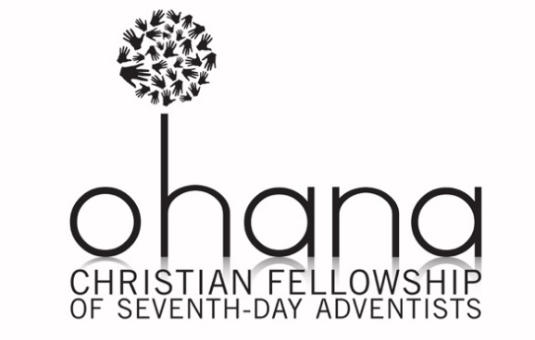

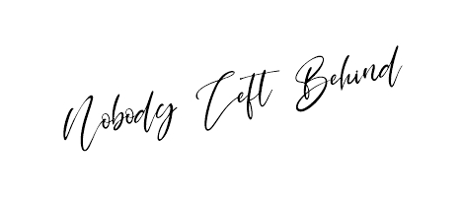

Sabbath April 26, 2025

