Gator Card Shop Order Form
Name: ___________________________
Room Number: _______________


A. B.


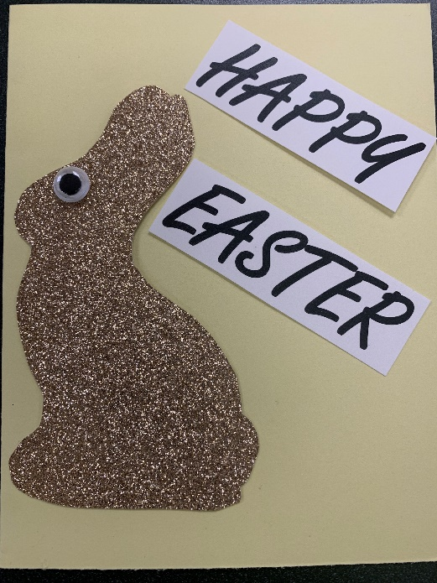
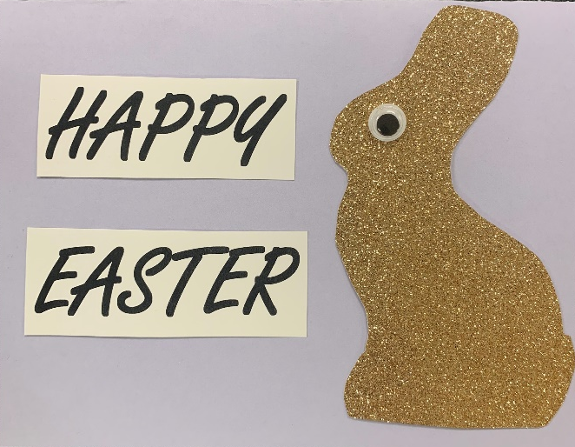
C. D.


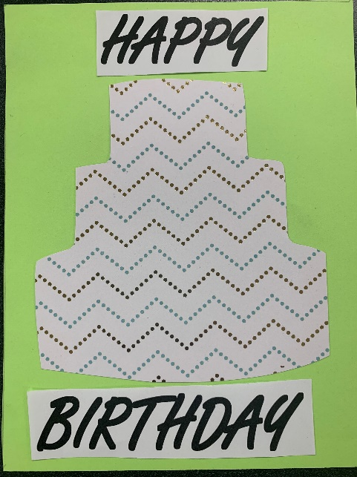
E. F.

Each card is $1.00 and comes with an envelope
**Card paper patterns may vary

Option Quantity:
A ____ B ____ C ____
D ____ E ____ F ____

Your total amount of cards _____ X 1.00= $________
*Orders are due by the end of the day Monday March 11th to the cash box outside of The Business Center (253). Thank you for your support!

