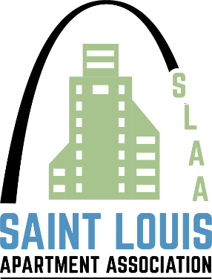
2023 CALL FOR NOMINATIONS/PRODUCT & SERVICE COUNCIL

Nominee Name /Title ________________________________________

Company __________________________________________________

Phone ______________________________________________________

Email _______________________________________________________

To be an effective council member you need to completely understand your duties and responsibilities.

Please read the following criteria very carefully before submitting this nomination. Nominations will not be accepted without your signature of acceptance.

Currently, there are 5 (five) seats open on the council.

An Informed Council Member is an Effective Council Member:

- Willing to give time and talents to promote the growth and success of the council
- Understands and is committed to the council’s purpose
- To serve the interests of all supplier members and allow open two-way communication to facilitate the group’s needs.
- To organize the supplier members of SLAA to further promote our goals and objectives with the SLAA
- To follow the Code of Ethics, Regulations of the SLAA, and principles adopted by the Council.
- Attends council meetings, actively participating in the conversation and contributing knowledge on behalf of your supplier partner colleagues
- Council members are encouraged to coordinate and support SLAA functions.
- Be an enthusiastic and knowledgeable voice for the council and association
- Be available to serve on the planning & instrumentation of specific events, to be determined by the council.
- Recognize your role as an important member of a team and a leader of the apartment industry, supporting policies which have been adopted by the council, even if you personally disagree

Important: With this signed “call for nominations”, please provide your bio and a narrative that describes the reasons why you would like to be elected to the Council, Lastly, after all the “call for nominations” are received,

In mid-February, the P & S council officers, along with the association executive will host a meeting with nominees to discuss the election process and council member responsibilities.

Those individuals elected to the SLAA Product & Service Council will serve a minimum term of three years beginning May 1, 2023, through April 30, 2026. Elections results will be announced on March 15th.

NOMINEE MUST SIGN THIS FORM TO ACCEPT THE RESPONSIBILITIES AND DUTIES OF A COUNCIL MEMBER, and fax to 314-205-1410 or scan and email to deb@slaa.org by Monday, February 6.

I understand that St. Louis Apartment Association is an association, which requires a commitment from its volunteer members to continue to grow. If elected, I agree to be an active council member and serve to the best of my ability. I hereby accept this nomination.

Signature Date

