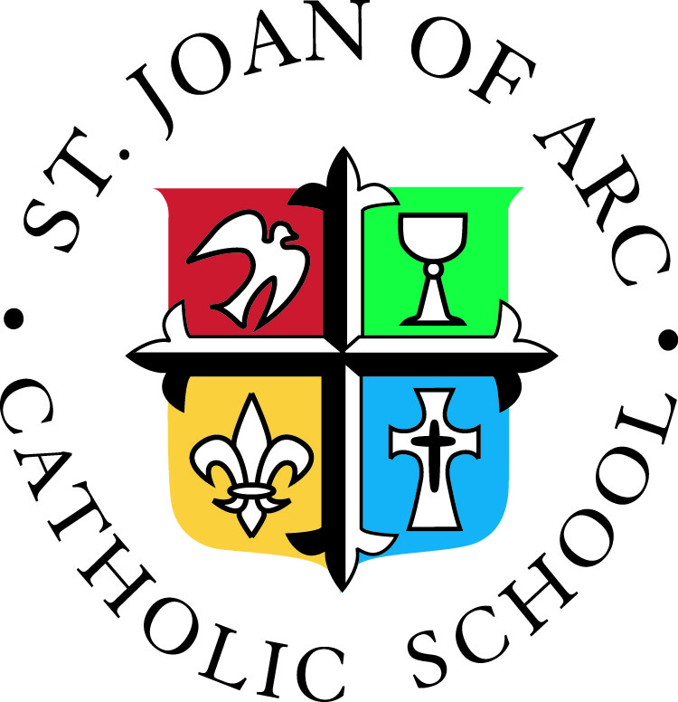
DRESS DOWN DAYS
2018-2019

Friday, September 21
Friday, October 12
Wednesday, October 17, SJA Goes Pink
Tuesday, November 6
Thursday, December 20
Friday, January 18
Friday, February 22
Friday, March 15
Friday, April 12
Thursday, May 16

