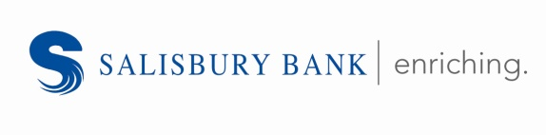
NEWS RELEASE

Contact:
Julianna Sinchak, Vice President, Marketing
Salisbury Bank and Trust Company
5 Bissell Street, Lakeville, CT 06039
860.453.3495
jsinchak@salisburybank.com
FOR IMMEDIATE RELEASE

SALISBURY BANK OFFERS BUSINESS MASTERY SERIES: MARKETING IN THE DIGITAL ERA

Lakeville, CT – September 26, 2019 – Salisbury Bank has partnered with Scoville Memorial Library and the Entrepreneurial Center of Northwest Connecticut to offer a free Business Mastery Series: Marketing in the Digital Era.
This 2-hour seminar will focus on how small to medium-sized businesses can improve their online visibility. Topics will include:
- Learning how to properly optimize your website for Search Engine Optimization (SEO).
- Understanding Search Engine Marketing (SEM) and the basics of placing Google Ads.
- Discovering the fundamentals of local search with Google My Business and Apple Maps and how to claim your business.
- Understanding the importance of on-line reviews from an SEO perspective.
Presenter:
Lance Leifert, CEO, Conquest Consulting
Lance brings over 20 years of experience in technology-oriented marketing and development. Lance holds a degree in Engineering and Computer Science from of the University of Connecticut and has been an adjunct professor at the University for over ten years. He formed Conquest in 1997 as a digital agency and then converted it to an integrated marketing agency in 2015 in response to the changing market. Conquest has helped clients of all sizes with the strategy and the implementation of cutting edge, integrated marketing programs. Under Lance’s leadership, Conquest has worked with clients including Hartford HealthCare, Aetna, Athena Healthcare, Hooker & Holcombe, United Technologies, Midstate Medical Center, and Connecticut Orthopedic Associates.
This seminar will take place on Thursday, October 17, 2019
6:00 p.m. – 8:00 p.m.
Scoville Memorial Library
38 Main Street
Salisbury, CT 06068

Reservations are suggested, but not required. To reserve a spot sign-up at salisburybank.com/seminar2.
You may also contact Genia Wilson by calling 860.453.3496, or email at evwilson@salisburybank.com (please type “Marketing” in the subject line).

Salisbury Bank is a full-service community bank headquartered in Lakeville, Connecticut and presently operates full service branches in Canaan, Lakeville, Salisbury, and Sharon, Connecticut; Great Barrington, Sheffield, and South Egremont, Massachusetts; as well as Dover Plains, Fishkill, Millerton, New Paltz, Newburgh, Poughkeepsie, and Red Oaks Mill, New York. The Bank has been serving families and businesses for over 170 years and offers a full range of consumer and business banking products and services as well as trust and investment services.

