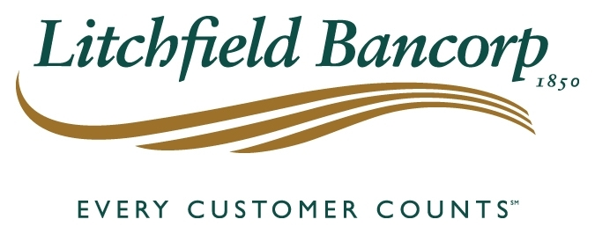
MEDIA CONTACT
Thomas J. Villanova
President
860.567.9401
FOR IMMEDIATE RELEASE

New Chair for Litchfield Bancorp Board of Directors

(Litchfield, CT) – Jane Hinkel has been elected Chairman of Litchfield Bancorp’s Board of Directors. Mrs. Hinkel has been a member of the Bank’s Board of Directors since 1994. She has also been a director of The Connecticut Mutual Holding Company, which consist of Litchfield Bancorp, Northwest Community Bank and Collinsville Bank since 2006 in addition to serving as Chair of Litchfield Bancorp’s Finance Committee as well as serving on the Executive, Strategic, Compensation and Loan committees.

Mrs. Hinkel holds a Bachelor of Arts Degree in Fine Arts and Marketing from the College of Mount St. Vincent and Manhattan College and is a Realtor with William Pitt Sotheby’s International Realty. Mrs. Hinkel also serves as President of the Litchfield Historical Society, on the Board of Directors for the Litchfield Garden Club and a member of the Litchfield Aid to Connecticut Junior Republic. In addition to her professional community involvement, Mrs. Hinkel volunteers for a variety of local non-profit organizations. She currently resides in Litchfield, CT with her husband.

Mrs. Hinkel’s election as Chair comes as Donald Mayland retires from Litchfield Bancorp’s Board of Directors after 41 years. Mr. Mayland was elected to the Bank’s Board of Directors in March of 1978 and Chairman in March 1994. He also served as Chairman of the Connecticut Mutual Holding Company from 2006 until 2016. When Mr. Mayland was asked to join the board in 1978, he was running the Mayland Chime Company in Lakeville, a family business, and was an economic teacher at the Hotchkiss School. His experience in business, combined with his knowledge of economics, was a perfect match for the board.

“Litchfield Bancorp is the only remaining community bank headquartered in Litchfield. Our Board is profoundly grateful to Don for his leadership over the years. That said, it was extremely important for the new board chair to be consistent in her approach to maintaining our stature in the community as was done by Don. Jane Hinkel is the perfect choice given her depth of involvement in the Litchfield Community” President and Chief Executive Officer Thomas J. Villanova said in announcing Mrs. Hinkel’s appointment.

# # #
ABOUT LITCHFIELD BANCORP
Litchfield Bancorp is a mutual savings bank with assets of $255 million offering full service offices in Litchfield, Torrington, Watertown, Washington and Lakeville. To find out why Every Customer Counts, go to LitchfieldBancorp.com or call 860-567-9401.
~ LitchfieldBancorp.com ~

