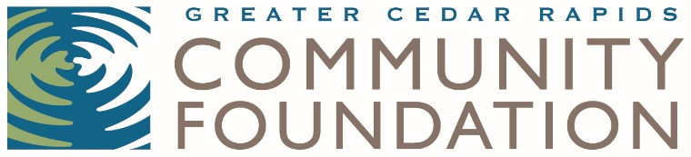
2019 NOMINATION FORM

Minnie Rubek Staff Excellence Award
For any staff member or team at a Linn County nonprofit organization,
other than the CEO/Executive Director

Minnie Rubek was an unsung heroine of our community. She worked as a member of the housekeeping staff at Interstate Power and Light for many years. Upon her passing, she left her estate to the Community Welfare fund—the predecessor of the Community Foundation—in what was a transformative gift for the organization and the greater community. Her work and dedication over many years made a lasting—albeit quiet—impact on the community as a whole.

With that idea in mind, the Minnie Rubek Staff Excellence Award honors a nonprofit staff member or team who has quietly gone “above and beyond” in their commitment and dedication to their organization and its mission, thereby enhancing the overall effectiveness of the organization. They are an unsung hero of the organization. This award is not intended for an organization volunteer, but can be awarded to a staff team. In 2019, we will be presenting one award.

The honoree will be selected by a committee of nonprofit peers. The award will be presented to a recipient at the Nonprofit Party at the Musuem hosted by the Greater Cedar Rapids Community Foundation on Thursday, November 7, from 4:30 to 6 p.m. at the Cedar Rapids Museum of Art, 410 3rd Ave SE, Cedar Rapids. The nominator and the honoree will be notified prior to the event.

Nominator Information
Name:
Organization Name:
Title:
Mailing Address:
Phone Number:
Email Address:

Nominee Information
Name:
Organization:
Number of years at the organization:
Title:
Mailing Address:
Phone Number:
Email Address:

Please provide a brief narrative (not to exceed 400 words) describing how the nominee meets the following Minnie Rubek Staff Excellence Award criteria: Describe the lasting impact this nominee has had on his/her organization and the community. The award recipient is someone who makes a unique contribution to the organization and the community, goes above and beyond in his/her work, and enhances the overall effectiveness of the organization.

Nominations are due by Tuesday, October 1, 2019 at 4:30 p.m.
Greater Cedar Rapids Community Foundation
Attn: Carrie Walker
324 3rd Street SE
Cedar Rapids, Iowa 52401
or
carrie.walker@gcrcf.org

If you have any questions, please contact Carrie Walker at 319.774.2375 or carrie.walker@gcrcf.org.

