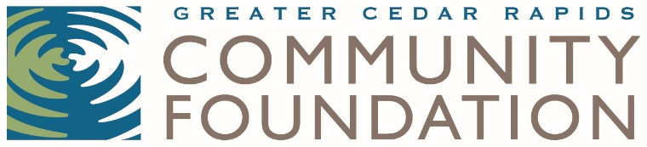

2019 NOMINATION FORM

Nonprofit Leadership Excellence Award
For the CEO/Executive Director at a Linn County nonprofit organization

The Nonprofit Leadership Excellence Award from the Greater Cedar Rapids Community Foundation seeks to honor the leadership and accomplishments of the chief executive officer of an organization who offers exceptional leadership, creativity, innovation, effectiveness, collaboration, and commitment. This award—formerly the Bridge Builder Award—recognizes an individual who creates a lasting impact on their organization and the community. In 2019, we will be presenting one award.

The honoree will be selected by a committee of nonprofit peers. The award will be presented to a recipient at the Nonprofit Party at the Museum hosted by the Greater Cedar Rapids Community Foundation on Thursday, November 7, from 4:30 to 6 p.m. at the Cedar Rapids Museum of Art, 410 3rd Ave SE, Cedar Rapids. The nominator and the honoree will be notified prior to the event.
Nominator Information
Name:
Organization Name:
Title:
Mailing Address:
Phone Number:
Email Address:

Nominee Information
Name:
Organization:
Number of years at the organization:
Title:
Mailing Address:
Phone Number:
Email Address:

Please provide a brief narrative (not to exceed 400 words) describing how the nominee meets the following Nonprofit Leadership Excellence Award criteria: Describe how the nominee creates a lasting impact on the organization and community. Please address each of the following: creativity, effectiveness, leadership, collaboration and commitment.

Nominations are due by Tuesday, October 1, 2019 at 4:30 p.m.
Greater Cedar Rapids Community Foundation
Attn: Carrie Walker
324 3rd Street SE
Cedar Rapids, Iowa 52401
or
carrie.walker@gcrcf.org

If you have any questions, please contact Carrie Walker at 319.774.2375 or carrie.walker@gcrcf.org.

