

Zone XI Photography Study Group is pleased to announce an exciting and educational opportunity.
Photography 101
Friday, April 13, 2018
9:30 – 4 pm
Chicago Botanic Garden, Glencoe IL
Instructors: Lou & Todd Nettelhorst
We will begin promptly at 9:00AM with Lou and Todd, of Nettelhorst Images, https://nettelhorstimages.com/. Our educational and fun-filled day will include introductions, review of submitted images, presentations on composition and basic camera tools, Hands-on shooting, and critique of images.
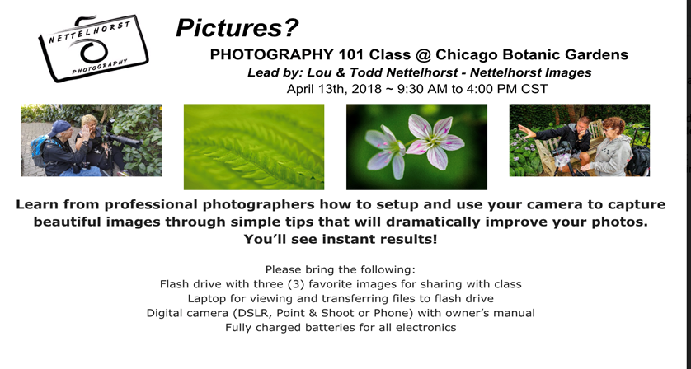
Registration will open at 9 a.m. on Thursday, January 25th. Please email flowergenius@gmail.com at 9:00 a.m. on Thursday, January 25, 2018 to secure your place. The first 22 respondents will be added to the workshop list.

We will keep a waiting list for those replying after. The first twenty-two will be notified and will need to send a check to be received by Feb. 10th. If checks are not received, the next person on the waiting list will be notified that they are in the workshop. Full payment for the workshop will be expected at the time of registration. The registration fee will be refundable if a participant has to withdraw prior to the workshop only if there is a waiting list and their spot can be filled.

Limited to 22 participants with a minimum of 10; class will be filled in the order in which registration forms are received, according to postmark date. Deposits are non-refundable unless your place can be filled from a waiting list.

For more information or registration information please contact Shelley Galloway, flowergenius@gmail.com

Registration Form Below:

Registration opens at 9 am on Thursday, Jan. 25. Registrations emailed before that time will not be accepted. To register, reply with the information below to my email address. Your email will serve as a date and time stamp.
Confirmed registrants will receive the information on check payee and address to which it should be sent. You will also need to sign and return a liability waiver for Nettelhorst Images.


NAME:

CLUB:

ZONE:

ADDRESS:

CITY/STATE/ZIP:

HOME PHONE:

CELL PHONE:

EMAIL:
What are your Camera(s) Make and Model:

Cost: $170
The all-inclusive fee includes coffee in the morning and box lunches (choices to be made in follow up email.) We will carpool to the garden to avoid parking fees for non-members.

Confirmation will be sent via email. The first twenty-two will be notified and will need to send a check to be received by Feb. 10th. IF checks are not received, the next registrants will be notified that they are in the workshop. Full payment for the workshop will be expected at the time of registration. The registration fee will be refundable if a participant has to withdraw prior to the workshop only if there is a waiting list and their spot can be filled.

This workshop is geared to Beginner/Advanced Beginner Photographers in GCA Clubs in our Zone.

