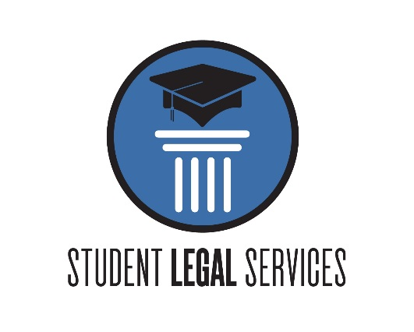
WINTER TIPS FOR TENANTS
INTRODUCTION
Everyone is looking forward to the finish of this semester and to the winter break ahead. Many international students travel within the US during the break. Others return home for an extended visit with their families. This article, which we present in a question-and-answer format, is intended to help you avoid some of the problems that students have experience during their winter travels.
Question: While I am gone over winter break, is it all right to turn off the heat in my apartment in order to save money?
This is NOT a good idea. Many students believe that it is all right to turn the heat off in their apartment unit during the winter while they are traveling. The few dollars that you might save in doing so are NOT worth the risk of causing extensive damage to your apartment. As you know, winters in Ohio can be very harsh and temperatures can fall far below freezing. Even if your apartment is on the inside portion of a very large complex, you cannot rely upon the heat from other units to sufficiently keep your unit warm enough to prevent the pipes from freezing.
Question: What happens if the pipes freeze?
When water pipes freeze, once heat is restored to the unit, or temperatures rise outside, the thawing action causes the pipes to burst. If the pipes burst, there is no valve to prevent the water from exiting the pipes. In other words, a great amount of water from the pipes will to spray throughout your apartment and causing flooding. If these damages are not discovered until you return, the moisture will remain in the apartment for several weeks and cause more extensive damage. Additionally, the flooding may leak down to apartments on floors below and cause damage to those apartments as well. Frozen water pipes may cause extensive damage, not only to your own personal belongings, but also to the structure of the apartment itself.
Question: Under these circumstances, who is responsible for replacement of my personal property and repairing any damages to the apartment?
Ohio’s Landlord and Tenant act found at section 5321 of the Ohio Revised Code requires that tenants refrain from intentionally or negligently damaging the landlord’s property. In other words, you would be legally responsible for reimbursing the landlord for the costs necessary to repair the damage caused by your actions. The landlord would not be responsible for replacing any of your belongings that were ruined.

Conclusion
For the reasons explained above, we strongly encourage you to leave your thermostat set at least 60°Fahrenheit. The small amount of money that you might save by either turning off the thermostat or setting the temperature below 60° Fahrenheit is not worth the risk of the thousands of dollars it may cost you. Additionally, we encourage you to purchase renter’s insurance. This protects you from liability in the event of accidental mishaps.
We hope that this information is helpful to you. If you have any questions or concerns pertaining to your obligations or rights under your lease agreement, or there are other legal matters with which we can assist you, we welcome you to contact student legal services to schedule an appointment. Phone: 330-672-9550

