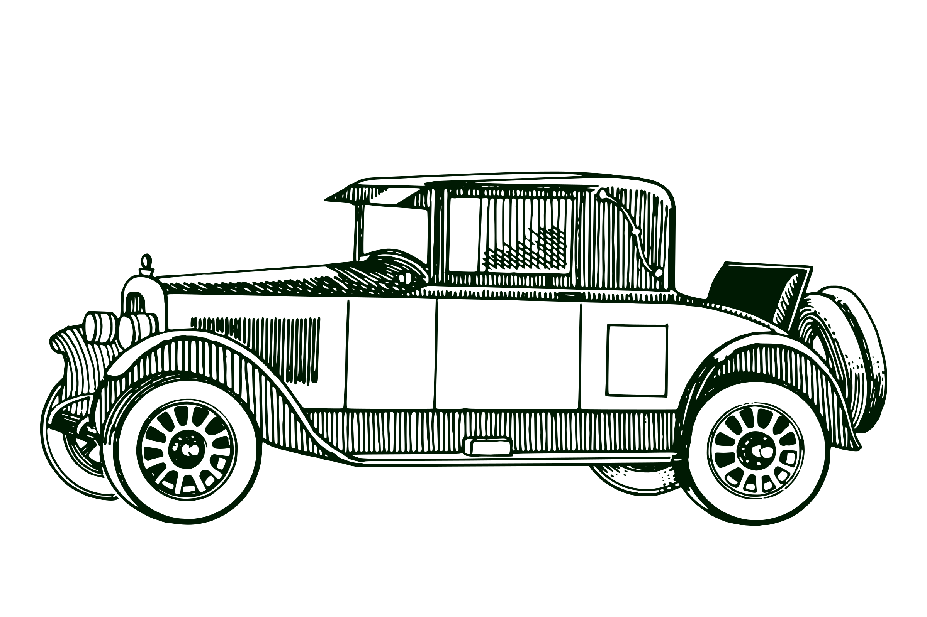
Twenty-Eighth Annual Classic
Automobile Show
Buggs Island/Kerr Lake-Clarksville, VA
Saturday, July 16, 2022
-Calling all owners of Classic Vehicles-
Bring your classic and enjoy all the activities at the Annual Virginia Lake Festival. There will be food, live entertainment, hot air balloons, arts & crafts booths, gathering of the boats, and a fireworks display on Saturday night. Show participants will have antique auto parking near it all– Touchstone Bank on Virginia Avenue! Yours does not have to be a show car to participate. $10 pre-registration or $20 at the show.
***ALL VEHICLES MUST HAVE A FIRE EXTINGUISHER***

Rules, Regulations, & Information
Saturday, July 16, 2022 8am-5pm
Please return applications to:
Clarksville Chamber of Commerce PO Box 1017 Clarksville, VA 23927
Email:
ClarksvilleLakeCountry@outlook.com

Make checks payable to: Clarksville Chamber of Commerce
*Spaces are limited and processed with application upon receipt of payment*

$10 Advance Registration $20 at the Show
Deadline for registration price break is July 10th, 2022

This is a rain or shine event—no refunds will be given

Every car that enters will be given an Annual Lake Festival Dash Plaque!

APPLICATION & WAIVER OF INDEMNITY
The Clarksville Lake Country Chamber of Commerce has arranged for the below named person to participate in the Classic Auto Show on July 16, 2022 on private property belonging to Touchstone Bank in Clarksville, VA.
I agree to abide by the following regulations and guidelines including but not limited to the following:
*No products which will endanger property
*All Vehicles MUST have Fire Extinguisher
*Cleanup after yourself before departing

I understand and agree that the Clarksville Lake Country Chamber of Commerce and Touchstone Bank including all directors, officers, agents, and employees will not be responsible for any liability that might occur during this show. Futhermore, I agree to hold the Clarksville Chamber of Commerce and Touchstone Bank including all directors, officers, agents, and employees blameless from any claims, actions, etc resulting from my occupation of the above mentioned property and any activities I may perform on that property.

Signed:_______________________________________________ Date:_____________________
Printed Name:_____________________________________________________________________
Address:__________________________________________________________________________
City/State/Zip______________________________________________________________________
Phone:________________________________ Email:______________________________________
Year of Auto:______________ Make:___________________ Body Style:_______________________
Year of Auto:______________ Make:___________________ Body Style:_______________________

Office Use Only— Date Received:______________________
Check/Cash___________________ $_______________________ Approved ____Y ____N

