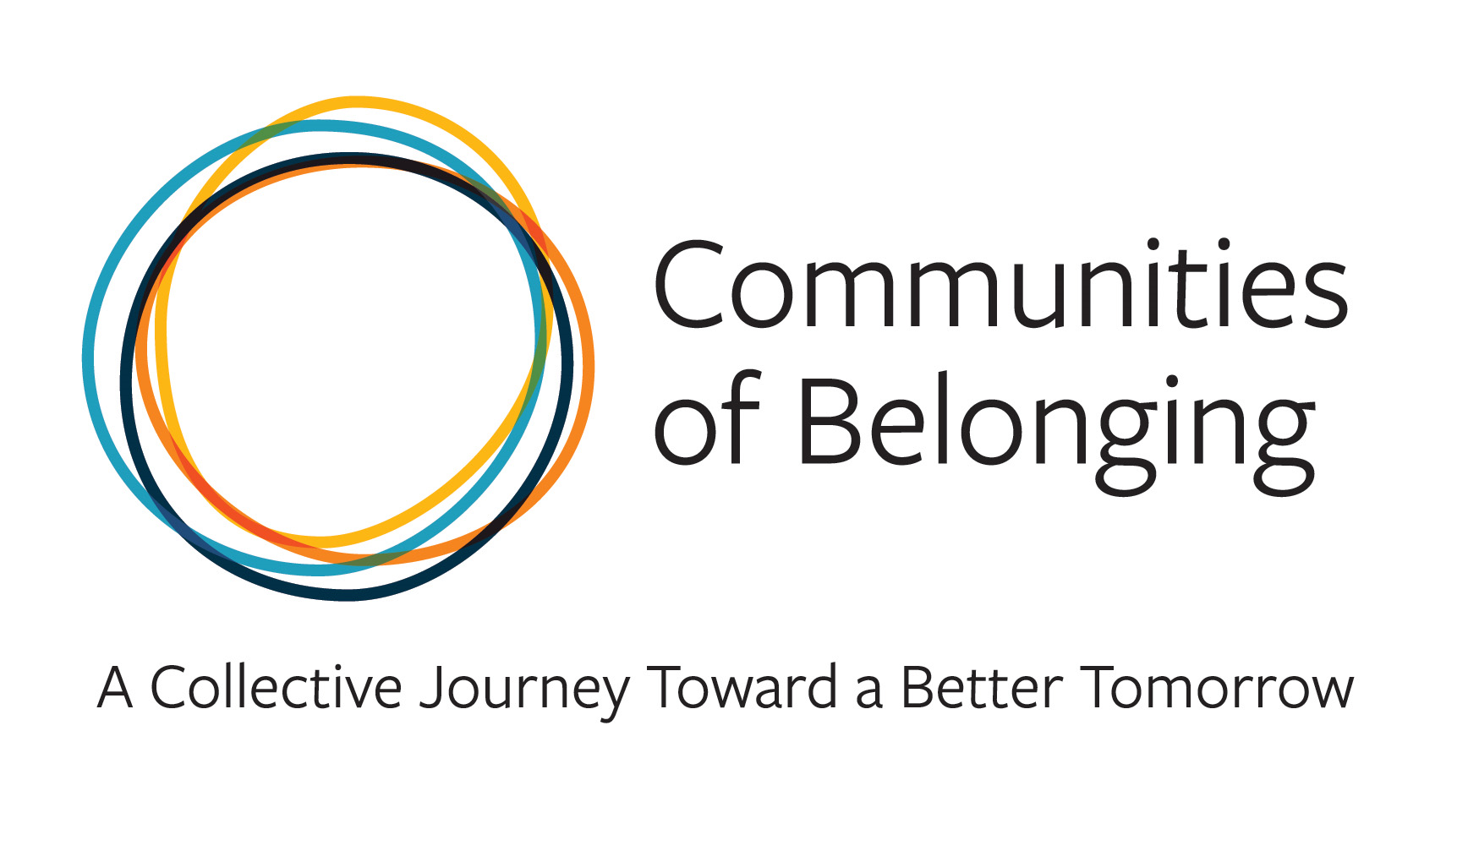

Weave the Social Fabric

Many people sense that something is broken in society. Surveys show about half of young adult Americans are lonely. We face rapid change from a globalized economy, cell phones and social media, job-hopping, online dating, immigration, and uncertainty about our future health and wealth.

Some feel that our social fabric seems to be shredding. Others observe that the social fabric of our communities and nation was never really woven to include everyone in the first place. Yet, there have been many times as a country when people looked past their surface differences and came together as neighbors to support each other.

With this conversation we will get to know each other a bit, share our experiences of both isolation and of connection, and we will consider how we might work together to build connections that allow us to feel recognized, respected and valued.

Below is a schedule of upcoming virtual sessions on this topic March 6-9, 2023. Feel free to join which ever session fits your schedule, as each session will be the same. Once you have identified your preferred session, simply contact Pat Stieg with the Carver County Public Health Department (pstieg@co.carver.mn.us) to receive a link to join.

Feel free to share this information with others who may want to join the conversation.
The more diverse the experiences are among the participants, the richer the conversations!

Like all of these Living Room Conversations, they are intended for us to learn about perspectives, experiences, beliefs and opinions that are different from our own - so we can bridge our divides and build a community of belonging for everyone.

Monday, March 6 - 6:30 pm Microsoft Teams meeting

Tuesday, March 7 - 3:30 pm Microsoft Teams meeting

Thursday, March 9 - 8:30 am Microsoft Teams meeting

Thursday, March 9 - 11:30 am Microsoft Teams meeting

