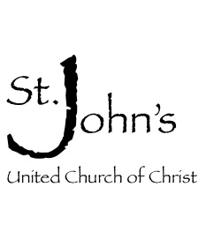

FOR IMMEDIATE RELEASE | Contact: Rev. Cathy M. Kolwey
 | Phone: 612-207-8972
 | Email: cmkolwey@hotmail.com

[VETERANS DAY PROGRAM AND LUNCHEON]

[TPT’s producer of “Minnesota Remembers Vietnam” to speak on Nov. 11]

[BONGARDS, MN, Sunday November 11, 2018—] St. John’s UCC will be hosting Emmy award winning producer Luke Heikkila on Veterans Day to speak about his work on the TPT original “Minnesota Remembers Vietnam.” Program begins at 11:30 am. A free will lunch will follow.

More details about speaker:
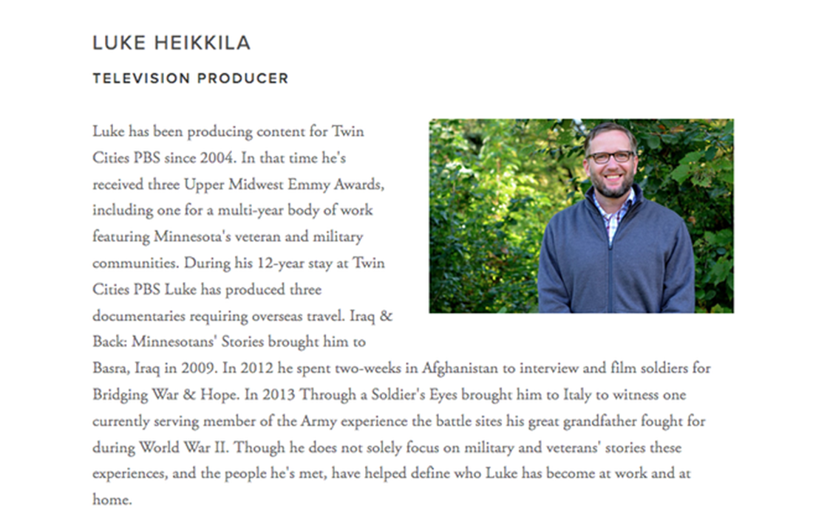

St. John’s United Church of Christ is a place where God is still speaking; a congregation determined to love our neighbors however we can, and to spread the good news whenever possible.

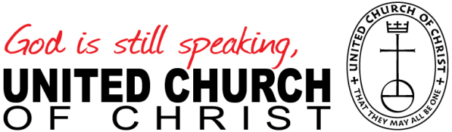
If you would like more information about this topic, please call Rev. Cathy M. Kolwey at 952-466-2080, or email cmkolwey@hotmail.com.

