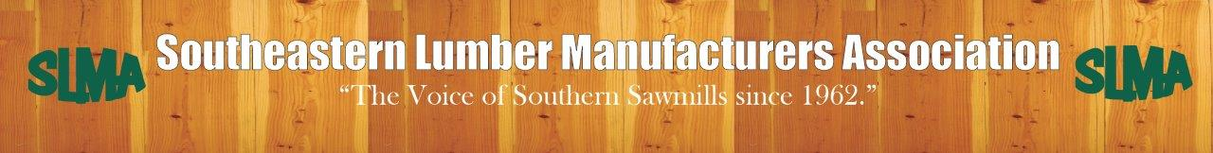
Environmental Issues

Sawmills provide a market for timber, which is necessary to be sure landowners plant trees that clean our air and water instead of converting the land to other uses. Sawmills also produce a building product that is inherently green, as trees pull carbon from the atmosphere and store it in building products, while by-products from our mills are used to produce energy, paper and packaging, landscaping materials, and more. SLMA monitors and advocates on a variety of environmental issues. Priority environmental issues include the current Plywood and Composite Wood Products Risk and Technology Review and Maximum Achievable Control Technology rulemaking, the need for a final EPA biomass carbon neutrality policy, and on-going litigation and related rulemakings regarding the 2015 Waters of the US rule.

SLMA supports a final biomass carbon neutrality policy at EPA. Biomass energy produced from wood products manufacturers’ residuals is an economic and environmental win. Sawmills utilize residuals to produce heat for drying lumber, while the excess residuals are an additional source of revenue when used to create renewable energy within the natural carbon cycle of trees or make other wood based products, such as paper.
- For many years, EPA policy treated biomass as carbon neutral, like the rest of the world. However, in 2010, EPA’s final Tailoring Rule, without public notice or a scientific basis, reversed that policy and for the first time regulated greenhouse gas emissions (GHG) from biomass the same as fossil fuels.

- The FY17, FY18, and FY19 omnibuses included Senate language directing EPA, DOE and USDA to create a policy that reflects the carbon neutrality of forest biomass. This language was originally adopted by unanimous consent on the Senate floor during consideration of the 2016 Energy Bill.

- Although EPA committed to reconsider and potentially revise its biomass policy by July 2014, it did not follow through on this commitment. Moreover, EPA’s Science Advisory Board failed to finalize a science report on biomass that it worked on for eight years. EPA has indicated in its Unified Regulatory Agenda that it will propose a rule in October.

- The current policy uncertainty has the potential to impose further regulations on sawmills that utilize biomass energy and put our products at a competitive disadvantage to those of other countries that recognize the carbon neutrality of biomass.
Please ask the EPA to finalize a permanent biomass carbon neutrality policy for wood products by the end of 2019 and support the biomass language that has been included in the last several appropriations bills.

SLMA supports EPA’s efforts to replace the expansive and confusing 2015 Waters of the US Rule with a clear definition of waters of the US.
- For decades, the scope of the Clean Water Act has been plagued by uncertainty and inconsistency.

- The agencies’ radical expansion of jurisdiction in the 2015 Rule swept in waters and lands with little or no relationship with navigable waters, creating confusion and raising serious federalism concerns. Multiple federal courts blocked the rule almost immediately after being finalized.

- The current proposed rule to replace the 2015 Rule provides long needed clarity as to what is and is not considered to be Waters of the US, protecting the water that is so important to everyone.

Please support the proposed rule to protect our waters and clarify what falls under federal jurisdiction.

