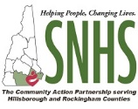
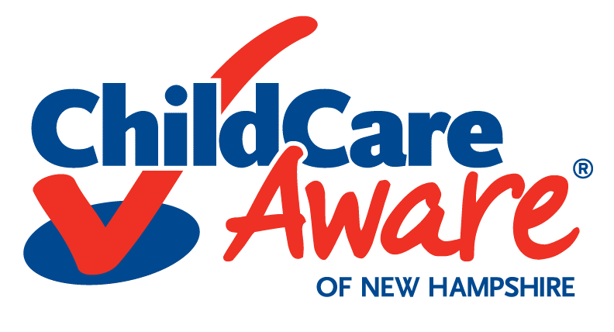
Exploring Strengthening Families
in Child Care Cohort (ESF Cohort) Application Form

Child Care Aware of New Hampshire powered by Southern New Hampshire Services
Please email application to ccrrtraining@snhs.org or mail it to
CCAoNH at 88 Temple Street, Nashua, NH 03060 by Monday, September 30, 2019.

Program Name: Click here to enter text. Program License ID: Click here to enter text.
Program Address/Region: Click here to enter text.
Contact Person and Role: Click here to enter text.
Email: Click here to enter text. Phone: Click here to enter text.
Program Capacity: Click here to enter text. Total Number of Staff: Click here to enter text.
Type of Program: Choose an item.
Exploring Strengthening Families in Child Care Cohort
Child Care Aware of NH, a Child Care Resource and Referral Program powered by Southern New Hampshire Services in collaboration with NH’s Children’s Trust and the State Early Learning Alliance (SELA), is offering the Exploring Strengthening Families (ESF) in Child Care Cohort. The ESF Cohort is intended for child care centers and family child care providers. Participating child care programs will walk through the five protective factors of supporting families, explore resources available to help families in their area and network with other programs focusing on Strengthening Families. This Cohort will allow programs to assess their current family engagement practices, identify resources that are available to both the program and families, as well as create goals to sustain change in their practice to ensure the support of our New Hampshire families.
Please respond to the questions below. Your responses will be used to assess your program’s eligibility and needs for this Cohort.
- Has your program participated in the Progressive Training and Technical Assistance Program (PTTAP) on Strengthening Families offered by Child Care Aware of New Hampshire?
☐ Yes (Year? Choose an item.) ☐ No ☐ Unsure

- Is your program a Strengthening Families Program? ☐ Yes ☐ No

If yes, what activities and/or supports are you currently offering families? Please describe:
Click here to enter text.
If yes, what additional support do you feel you need to implement the Strengthening Families Approach in your program? Click here to enter text.

- Have you or any of your staff completed any training on Strengthening Families or Bringing the Protective Factors to Life Online or Face-to-Face Modules? ☐ Yes ☐ No ☐ Unsure

If yes, which one(s): Click here to enter text.

- What other training, if any, have you or your staff taken on Strengthening Families? If no one has had training on this topic, please leave blank.
Click here to enter text.

- Has your program completed the program self-assessment on Strengthening Families?
☐ Yes ☐ No ☐ Unsure

- When considering your family engagement approach, how would you rate your prior knowledge and competence in the following topics:
Please rate your competence level, on a scale of 1 to 5, check the box that applies.
 | 5-Highly Competent | 4-Very Competent | 3-Competent | 2-Fairly Competent | 1-Not Competent
Self-Assessment Process | ☐ | ☐ | ☐ | ☐ | ☐
Five Protective Factors | ☐ | ☐ | ☐ | ☐ | ☐
Strengthening Families Approach | ☐ | ☐ | ☐ | ☐ | ☐

- Are you able to meet with this cohort bimonthly? Choose an item.

- Meetings will be held between 10:00 am & 3:00 pm, please select your preferred meeting time? Choose an item.

- What day of the week is best for you? (Check all that apply):
☐ Monday ☐ Tuesday ☐ Wednesday ☐ Thursday ☐ Friday ☐ Unsure

- Are you open to hosting the cohort meeting at your location (Please note your location must have adult seating)? Choose an item.

Child Care Aware of New Hampshire is a Child Care Resource and Referral Program powered by Southern New Hampshire Services in collaboration with NH Children’s Trust and the State Early Learning Alliance is offering the ESF Cohort. The preparation of this application was financed under a Contract with the State of New Hampshire, Department of Health and Human Services, Division of Economics and Housing Stability, Bureau of Child Development and Head Start Collaboration with funds provided in part by the State of New Hampshire and the US Department of Health and Human Services.
