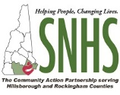
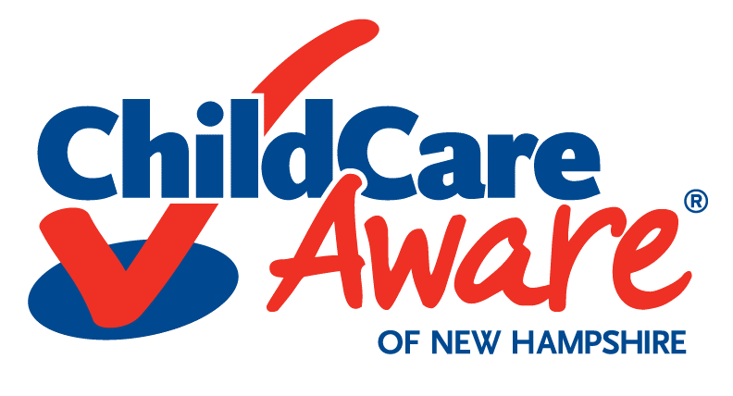
Progressive Training and TA Program
Center-Based Program Application Form

Child Care Aware of New Hampshire powered by Southern New Hampshire Services
Please email application to ccrrtraining@snhs.org or mail it to
CCAoNH at 88 Temple Street, Nashua, NH 03060 by Monday, September 30, 2019.

Program Name: Click here to enter text. Program License ID: Click here to enter text.
Program Address/Region: Contact Person and Role:

Email: Click here to enter text. Phone: Click here to enter text.

Program Capacity: Click here to enter text. Total Number of Staff: Click here to enter text.

Type of Program: ☐ Child Care Center ☐ Preschool Program

Please review and select your preferred Training and Technical Assistance (TA) Option for this Program from the five options: Option 1 Progressive Professional Development of Staff, Option 2 Program Emergency Preparedness and Response, Option 3 Strengthening Families, Strengthening Care, Option 4 NH Early Learning Standards and Option 5 Infant & Toddler Team Initiative. Please select up to 3 options, please note if the option is your 1st, 2nd, or 3rd choice. Programs will only be selected for ONE Training and TA Option.
Training & TA Option 1: Progressive Professional Development for Staff (PPDS)
This Training & TA Option supports programs to cultivate a continuous quality improvement through meaningful and intentional professional development opportunities. This Progressive consists of navigating the NH Professional Registry, assessing individual knowledge and skills using teacher competencies, creating annual professional development plans and applying for individual credentials and/or endorsements through the NH Early Childhood Professional Development System. Please respond to the questions below. Your responses will be used to assess your program eligibility and needs for this initiative.

Training & TA Option 1, Progressive Professional Development for Staff (PPDS), is my Choose an item.

Has your program staff completed their full registry record in the NH Professional Registry, including employment and education information? Choose an item.

Has your staff registered for training through the NH Professional Registry? Choose an item.

What percentage of your program staff are currently credentialed under the Early Childhood Professional Development System? Choose an item.

What percentage of your program staff have utilized either the Infant and Toddler Workforce Specialized Competencies, Preschool Workforce Specialized Competencies and/or Early Childhood Workforce Specialized Competencies? Choose an item.

Do you have your staff complete professional development plans? ☐ Yes ☐ No ☐ Unsure

Training & TA Option 2: Program Emergency Preparedness and Response (PEPR)

This Training & TA Option supports programs to establish a strong Emergency Response Plan, aid in
initiating Emergency Preparedness response drills within your program and in turn, have your program have a solid, well-developed and well-practiced Emergency Preparedness Plan. In addition, this option will help programs create a viable Continuation of Operations Plan (COOP). Please respond to the questions below. Your responses will be used to assess your program eligibility and needs for this initiative.

Training & TA Option 2, Program Emergency Preparedness and Response (PEPR), is my Choose an item.

Does your program have an emergency plan? Select one. ☐ Yes ☐ No ☐ Unsure
What does your emergency plan include?

What response drills does your program practice on a regular basis? How often do you practice each drill?
☐ Fire Drills: Choose an item. ☐ Drop, Cover and Hold: Choose an item.
☐ Secure Campus: Choose an item. ☐ Shelter-in-Place: Choose an item.
☐ Lockdown: Choose an item. ☐ Evacuation: Choose an item.
☐ Reverse Evacuation: Choose an item. Please specify if you choose other: Choose an item.

What training, if any, have you or your staff taken on emergency preparedness and response? If no one has had training on this topic, please leave blank.

Does your program have a formalized chain of command for how emergencies are handled? Please describe.

Training & TA Option 3: Strengthening Families, Strengthening Care (SFSC)

This Training & TA Option supports your program in assessing your current staff and program relationships with families. Through this assessment, CCAoNH will assist your program in implementing the Strengthening Families Approach to enhance communication, strengthen family engagement and to promote quality practices that support the social and emotional development of the children in your care. Please respond to the questions below. Your responses will be used to assess your program eligibility and needs for this initiative.

Training & TA Option 3, Strengthening Families, Strengthening Care (SFSC), is my Choose an item.

Is your program a Strengthening Families Program? ☐ Yes ☐ No ☐ Unsure

If yes, what activities and/or supports are you currently offering families? Please describe:

If yes, what additional support do you feel you need to implement the Strengthening Families Approach in your program?

Have you or any of your staff completed any training on Strengthening Families or Bringing the Protective Factors to Life Online or Face-to-Face Modules? ☐Yes ☐ No ☐ Unsure
If yes, which one?

Has your program completed the program self-assessment on Strengthening Families? ☐ Yes ☐ No ☐ Unsure

Training & TA Option 4: NH Early Learning Standards (ELS)
This Training & TA Option supports programs in understanding and implementing the NH Early Learning Standards and applying those Standards into their practice. Through this option, CCAoNH will assist your program in implementing the NH Early Learning Standards into practice to support the development of the children in your care. Please respond to the questions below. Your responses will be used to assess your program eligibility and needs for this initiative.

Training & TA Option 4, NH Early Learning Standards (ELS), is my Choose an item.
Does your program currently use the NH Early Learning Standards as part of your practice?
☐ Yes ☐ No ☐ Unsure

If yes, what activities and/or ways do you use the NH ELS in your program and in your practice?
Please describe:

If yes, what additional support do you feel you need to implement the NH Early Learning Standards into your program?

Have you or any of your staff completed any training on the Early Learning Standards or former Early Learning Guidelines? ☐ Yes ☐ No ☐ Unsure

If yes, which one(s):

Do you inform and/or educate families on the NH Early Learning Standards? ☐ Yes ☐ No ☐ Unsure

If yes, how?

Training & TA Option 5: Infant & Toddler Team Initiative (ITTI)
This Training & TA Option is specifically for Infant and Toddler Teaching Staff and those individuals caring for infants and toddlers in an early childhood setting. This option consists of navigating the NH Professional Registry, assessing individual knowledge and skills using the Infant and Toddler Competencies, creating annual professional development plans and having them apply for their individual credential and the Infant/Toddler Endorsement through the NH Early Childhood Professional Development System. Participants will be supported in gaining a deeper understanding of implementing the NH Early Learning Standards and applying those Standards into their practice. Through this option, CCAoNH will assist those serving infants and toddlers in implementing the NH Early Learning Standards to improve their competencies and their overall practice in caring for infants and toddlers. Please respond to the questions below. Your responses will be used to assess your program eligibility and needs for this initiative.

Training & TA Option 5, Infant Toddler Team Initiative (ITTI), is my Choose an item.

How many Infant and Toddler Staff/Individuals do you have that would participate? Click here to enter text.

How many infants and toddlers are currently enrolled in your program? Click here to enter text.

Are your Infant and Toddler Staff currently credentialed? ☐ Yes ☐ No ☐ Unsure

If yes, how many hold the Infant/Toddler Endorsement? Click here to enter text.

Do you currently have staff utilizing the Infant/Toddler Competencies? ☐ Yes ☐ No ☐ Unsure

Do you currently have staff using the NH Early Learning Standards in their practice?
☐ Yes ☐ No ☐ Unsure

If yes, what additional support do you feel you need to implement the NH Early Learning Standards into your program for Infants and Toddlers?

Have you spoken to your Infant and Toddler Staff about participating in this initiative? ☐ Yes ☐ No

If yes, what are their thoughts?

Child Care Aware of NH, a Child Care Resource and Referral Program is powered by Southern New Hampshire Services. The preparation of this application was financed in part or in whole under a Contract with the State of New Hampshire, Department of Health and Human Services, Division of Economics and Housing Stability, Bureau of Child Development and Head Start Collaboration, with funds provided in part by the State of New Hampshire and the United States Department of Health and Human Services.

