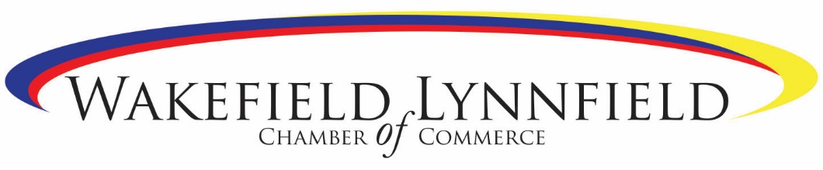

Wakefield/Lynnfield Chamber Members—
Meet with a State Official to Discuss How to Grow Your Business!
We are very pleased to announce that on Wednesday, January 9, 2019 we have 2 business development professionals available at The Savings Bank to meet with you to discuss your specific business needs, and state-provided resources that may be available to meet those needs.
Maria Nigro Di Stefano, Northeast Regional Director, Mass Office of Business Development
- Overview of State’s Economic Development Incentive Program
- Information regarding other State programs to benefit businesses, such as: Mass Life Sciences Center, Massachusetts Small Business Development Center, Workforce Training Fund, MassEcon MassCEC
Noreen Hazelton, Assistant Director of the Enterprise Center at Salem State University.
- Information about the many resources including programs, education and connections that help businesses start, grow and succeed
Appointments available are first come first served by emailing John Smolinsky john@wakefieldlynnfieldchamber.org
Date: Wednesday, January 9, 2019
Location: The Savings Bank 357 Main Street, Wakefield
Times:
- 9:00AM-9:30AM
- 9:30AM-10:00AM
- 10:00AM-10:30AM
- 10:30AM-11:00AM

