Introducing

im3:
Immigrant Mask Makers of western Mass

A group of immigrant women
in western Massachusetts
trying to make a living
amidst COVID-19.

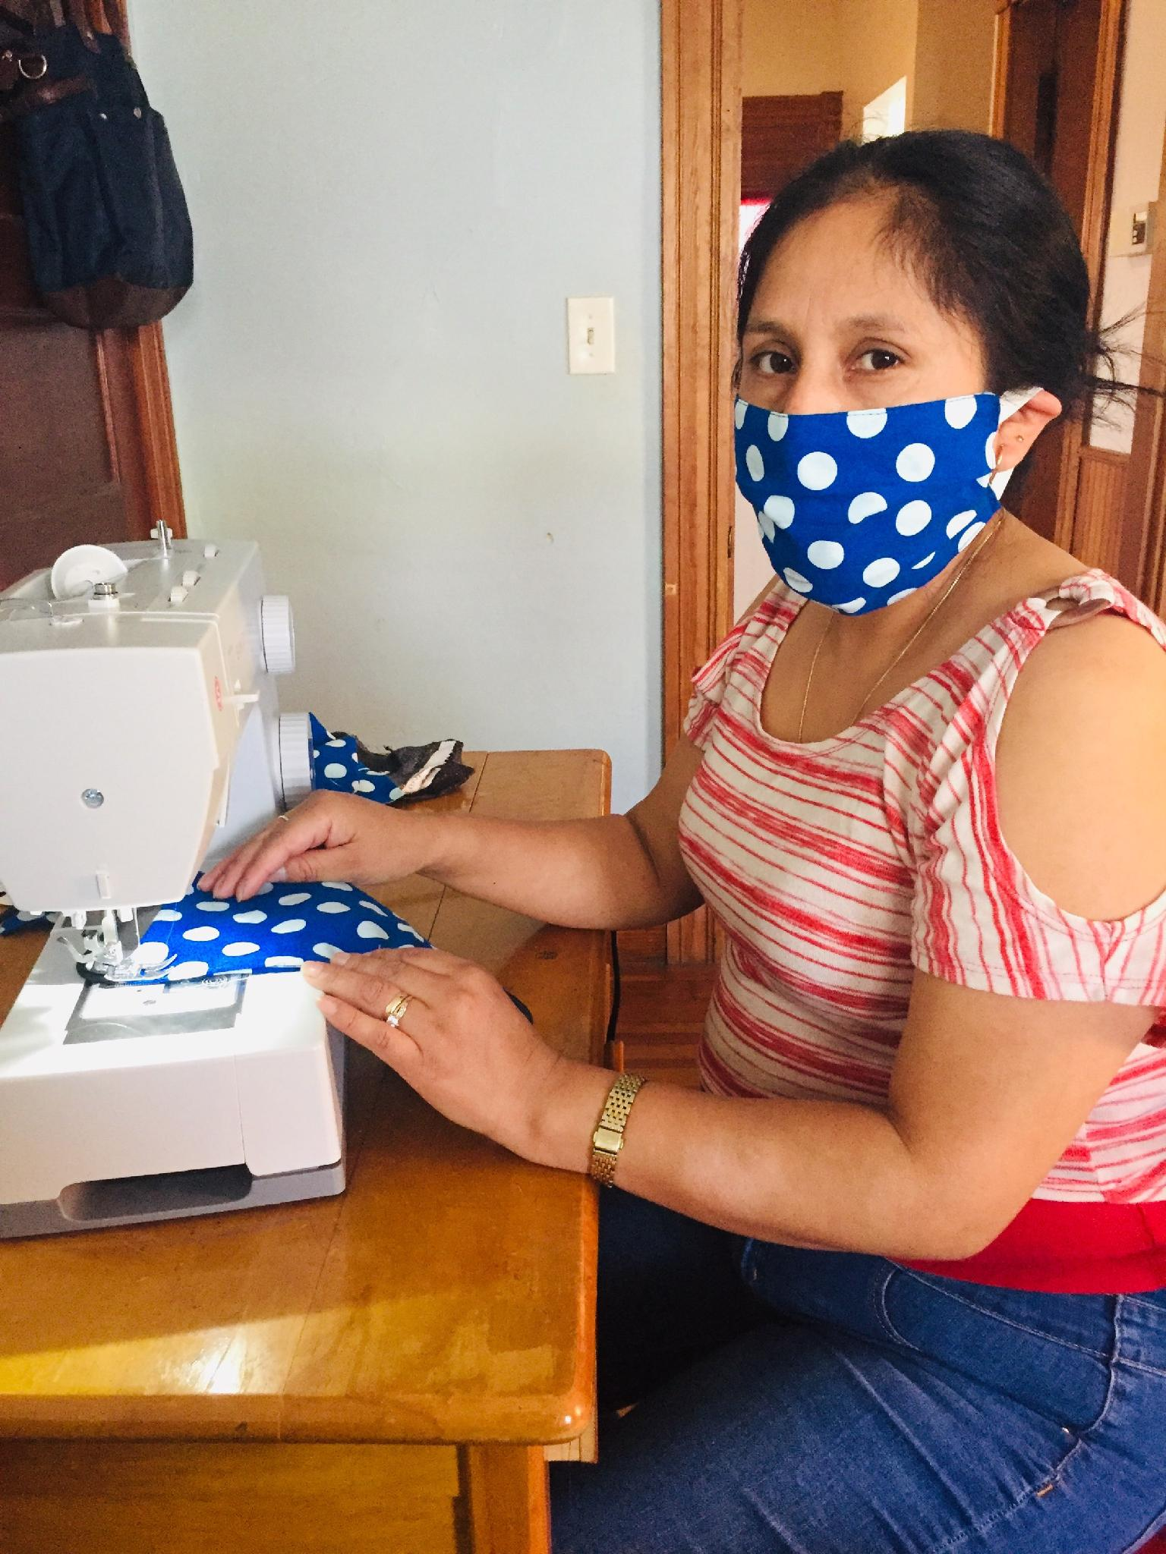

Introducing im3:
Immigrant Mask Makers of western Mass
Masks for You; Jobs for Us.

We are a group of immigrant women in western Massachusetts
trying to make a living amidst COVID-19. We are not eligible for
unemployment, stimulus money, small business aid, or any other government assistance. We are just starting a new, non-profit venture to support ourselves and our families. We strive for fair wages and fair prices.

We make face masks that are:
high-quality,
pre-shrunk,
double-layer,
100% cotton
quilters fabric,
nose pieces,
chin darts,
washable,
and reusable.
Made under sanitary conditions.
All our masks come with washing and use instructions
(currently available in 15 languages).

For more information, to donate, or to place an order,
Click this link

im3:
Immigrant Mask Makers of western Mass

So far, we are 15 immigrant Pioneer Valley women (and 1 US-born woman) sourcing sewing machines and materials, cutting the fabric and sewing masks for sale. We are also in the early stages of designing masks that meet the needs of people with various disabilities (lip readers,
one-handed people, people with hearing aids) and we welcome ideas. We are busy starting to
build up our inventory, and getting a few small mask orders.

We are excited to be making something that is in dire need right now, and seems it will be for
some time to come. We appreciate having a way to contribute during COVID-19, and still support
our families.

We have received donations of fabric and some sewing machines, but need more. We also need volunteers to help with cutting fabric to make kits, distribution of materials to sewers, and shipping. And we need start-up cost monetary donations, to pay for machine repairs; an ongoing supply of thread, needles, elastic, & filters; and a website platform, while we wait to have enough sales to cover these costs, on-going.

If you'd like to donate sewing machines, money, or your time;
or have ideas for the specialty masks, please contact:
Amy Ben-Ezra at <masksandjobs2020@gmail.com>

Masks for You; Jobs for Us.

Below is a listing of what we offer.

Choice of:
___No filter. ___Permanent non-woven filter ___Filter pocket to add filter
Sizes:
___Child ___Teen/Small Adult. ___Regular Adult, and ___XL Adult.
Adaptive masks:
upon request (different ties, adapted to disabilities, chemically sensitive).*
Patterns:
Currently making 3-pleat masks with nose pieces and elastic ear pieces.
Will be adding "Nurse-Preferred-Style" masks soon.
Will add cup-shaped masks in the not-too-distant future.
Fabric Designs:
Masks are made of colorful prints, solids, denim, stripes, plaids.
Some themes (golf, soccer, trucks, florals) and children's themes available.
Let us choose, or request something particular (i.e. children's, sports, stripes,
office professional, masculine, calm, lively).
Prices (currently):
$10 per mask or 3 for $25
Standard shipping price will be provided when order is received.

CONTACT: MASKSANDJOBS2020@GMAIL.COM

