Recipe Photo Ideas for Victoria & Melvin
Send image Maggie Wentzky (email, text or mail) by the first week of May
Include your name
Make it a recipe that is special to you
Handwrite it (if your handwriting is legible)

You can just write it: Get Artsy:
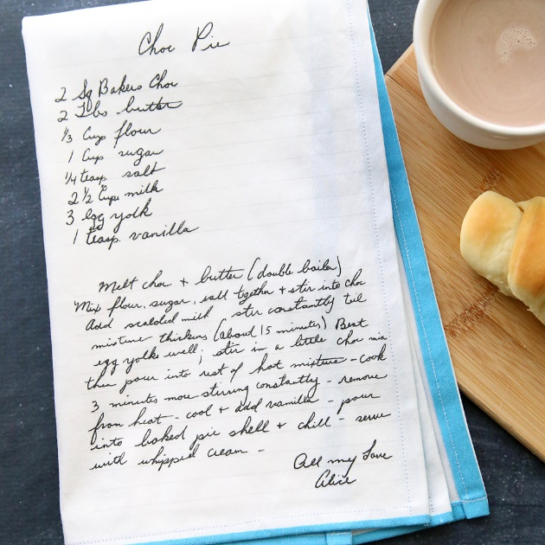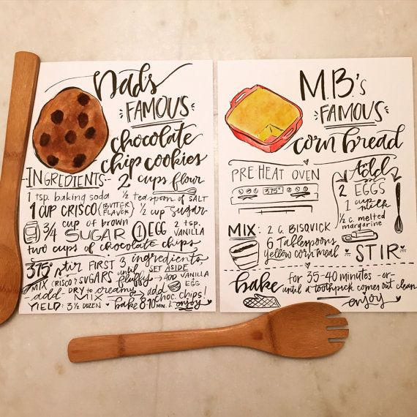

Keep it simple and fill out a recipe card:
