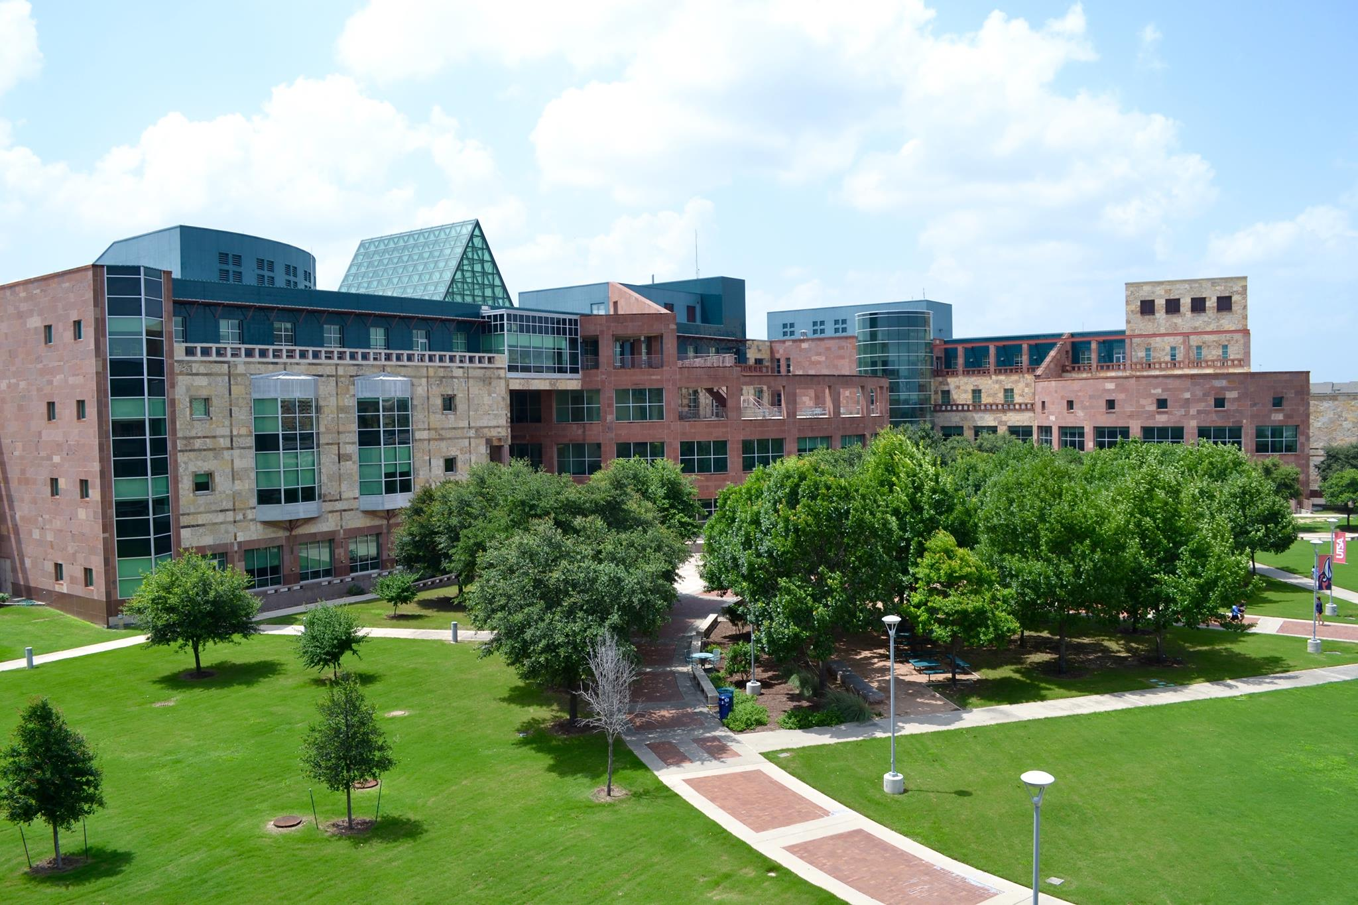

2018 Texas Mentoring Summit

January 11 & 12, 2018

**The Texas Mentoring Partnership** invites you to join us for the 6th Annual ***Texas Mentoring Summit*** and Mentor Recognition Awards, **January 11 & 12, 2018** at the **University of Texas at San Antonio Downtown Campus** in San Antonio, Texas.  This year's summit, ***Mentoring: A Pathway To and Through College & Career***, will focus on the positive impact mentoring can have on student success from K-12 through college and beyond.

This special event will honor outstanding mentors and programs, feature inspiring presentations and keynote speakers, and provide a chance for guests to network with leading mentoring professionals and mentoring advocates from across Texas. [**https://utsa.givepulse.com/group/8541-2018-Texas-Mentoring-Summit**](https://utsa.givepulse.com/group/8541-2018-Texas-Mentoring-Summit)

Belinda Saldana Harmon, TMP Lead

|  |  |  |  |
| --- | --- | --- | --- |
| **_________________________________________________________________________________________________________**   |  | | --- | | **Nominate an outstanding mentor, program, or advocate.** Winners selected will receive free admission to the luncheon for themselves and one guest. <https://goo.gl/forms/QeSDyJp28T9vkIWt2> | |  | | **6th Annual Texas Mentoring Summit Award Nomination Form Deadline: Friday, December 1, 2017** | |

-----------------------------------------------------------------------------------------------------------------------------

**Call for Proposals**

The call for proposals is now open.   Proposals selected will receive discounted registration. Please submit by November 7th. **Please fill out the proposal form:** <https://goo.gl/forms/ady9ZegJD92RWwlS2>

**6th Annual Texas Mentoring Summit Call for Proposals Deadline: Tuesday, November 7, 2017   
Conference Dates: January 11 -12, 2018**

-----------------------------------------------------------------------------------------------------------------------------

**Register Today!**

***General registration -$150, Students- $125*** <https://giving.utsa.edu/page.aspx?pid=1653>

**Like us on Facebook** [**https://www.facebook.com/TexasMentoringPartnership/?fref=ts**](https://www.facebook.com/TexasMentoringPartnership/?fref=ts)

----------------------------------------------------------------------------------------------------

The **National Mentoring Summit** will be held **January 24-26, 2018 in Washington DC.** [**http://www.mentoring.org/national_mentoring_summit**](http://www.mentoring.org/national_mentoring_summit)

** The University of Texas at San Antonio™**

**The Institute for P-20 INITIATIVES www.utsa.edu/p20**