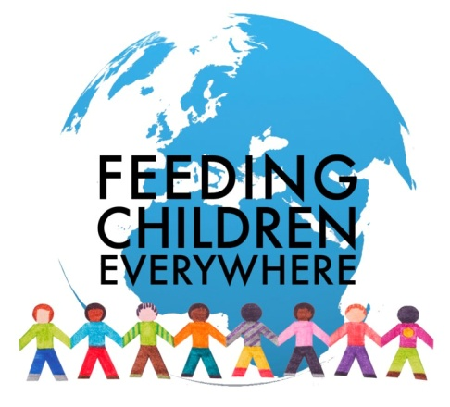

Feeding Children Everywhere
During VBS the children’s daily offering was collected to help the Board of Outreach bring Feeding Children Everywhere to FCCWP.
We hope you and your family can come and be part of a great event that YOU helped make happen! Come and help package 10,000 meals to aid in the fight against hunger.
All ages welcome!
When: Sunday, October 8th, 2017
Time: 11:30 to 1:30 (a light lunch will be served during the event)
Feeding Children Everywhere will bring all the materials for volunteers from our church to assemble the food packets. The rice-lentil casserole is fortified with essential vitamins and minerals as well as dehydrated vegetables. This protein and nutrient-rich formula improves both children’s physical health and their mental capacity to learn.
Because Feeding Children Everywhere uses a volunteer-driven food packaging process, each serving only costs about 25 cents. Our food packets will be distributed in the United States where they may go home in school backpacks or help feed homeless families.
We hope on Oct. 8th, you will join with your church family and volunteer your time to help make a difference in the life of a hungry child!
