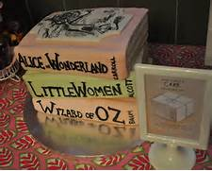
October 29th after church
Pumpkinfest Lunch
Tickets $5.00 children & $10.00 youth–adult
Raffle tickets will be on sale for prize giveaways!
Or be part of the contest!
Here is how it works…
Put a team together of 8 people. A team of 8 is $100 to purchase a table. This includes table, lunch, dessert and 20 raffle tickets.
*Your team is in charge of decorating the table. Use your imagination, creative talents and even yourself to make the most festive table in the room. Your table needs to be the theme of your favorite storybook.
*The lunch will begin with all in attendance getting voting cards and deciding who will be the winner. While everyone enjoys lunch the votes will be tallied. The winner will be announced after the last raffle drawing
First Place winner will pick their prize, followed by second and third place winners!
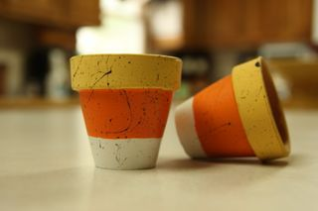
Good Luck!
Kids Check Out
Come and make a candy corn
Candle holder

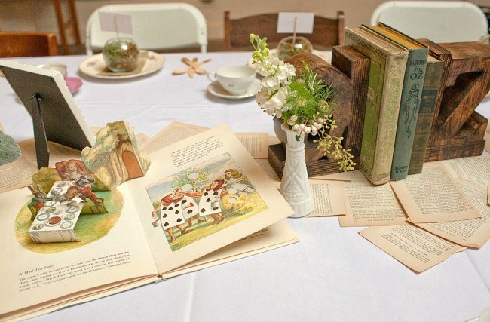

------------------------------------------------------------------------------------------------------
We would like to purchase a table for the contest!
Name/Team__________________________________________________________
Contact Phone number___________________________________________________
Contact Email _________________________________________________________
Paid______ Cash______ Check_______
Date purchased__________________

